Requirement & Design Specification
Global Access Management System (GAMS)
Version: 1.0

– Hanoi, August 2022 –

Record of Changes
Version | Date | A*  M, D | In charge | Change Description
V1.0 | 15/2 | A | KienNTHE11
*A - Added M - Modified D - Deleted

Contents
Record of Changes 2
I. Overview.. 4
1. User Requirements 4
1.1 Actors 4
1.2 Use Cases 4
2. Overall Functionalities 5
2.1 Screens Flow.. 5
2.2 Screen Descriptions 5
2.3 Screen Authorization. 5
2.4 Non-UI Functions 6
3. System High Level Design. 6
3.1 Database Design. 6
3.2 Code Packages 7
II. Requirement Specifications 8
1. <<Feature Name>>. 8
1.1 <<UseCaseCode_UC Name>>. 8
2. Common Functions 11
2.1 UC-2_Login System.. 11
3. Patron Feature. 12
3.1 UC-5_Order a Meal 12
3.2 UC-6_Register for Payroll Deduction. 13
III. Design Specifications 14
1. <<Feature Name>>. 14
1.1 <<SubFeature Name>>. 14
1.2 System Access 15
IV. Appendix. 19
1. Assumptions & Dependencies 19
2. Limitations & Exclusions 19
3. Business Rules 19
4. .. 19

I. Overview

1. User Requirements

1.1 Actors
# | Actor | Description
1 | Admin | -System administrators responsible for the overall operation of the platform. -They manage core database entities (movies, cinemas, screening halls, showtimes), configure business rules (pricing, vouchers), moderate user reviews, and extract revenue reports.
2 | Guest | -Unregistered users who access the system to browse information.  -They can look up movie catalogs, search for cinema branches, view showtimes, and read promotional news without needing an account.
3 | Customer | -Registered members who inherit all Guest privileges.  -They can perform online transactions such as booking seats in real-time, purchasing F&B combos, applying vouchers, managing personal profiles, and interacting with the AI recommendation/chatbot system.

1.2 Use Cases

a. Diagram(s)
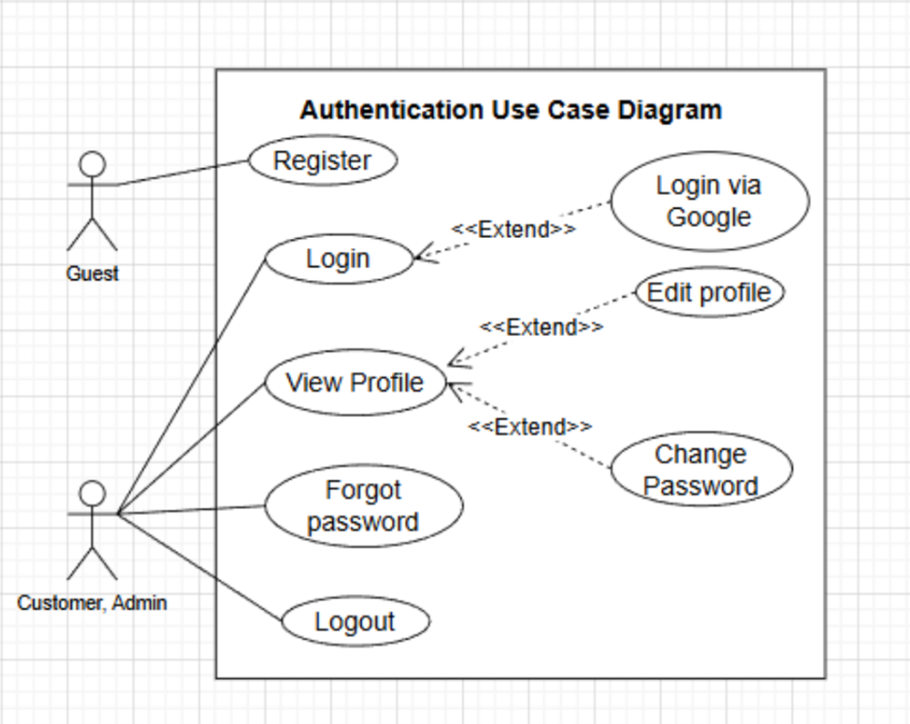
Figure 1. Authentication use case diagram
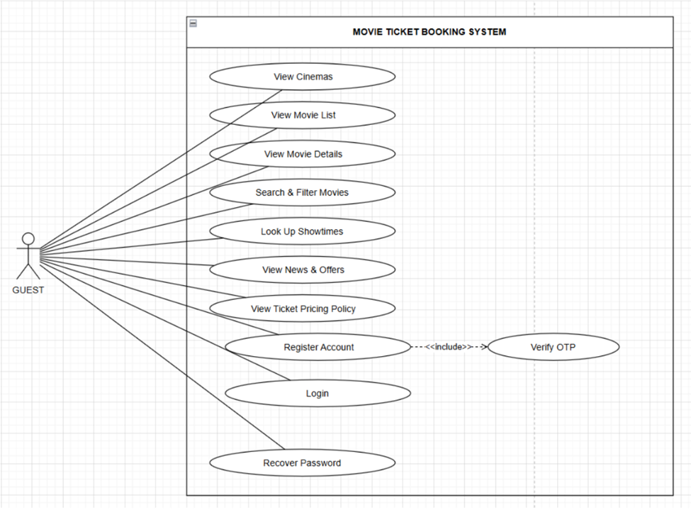
Figure 2. Guest use case diagram

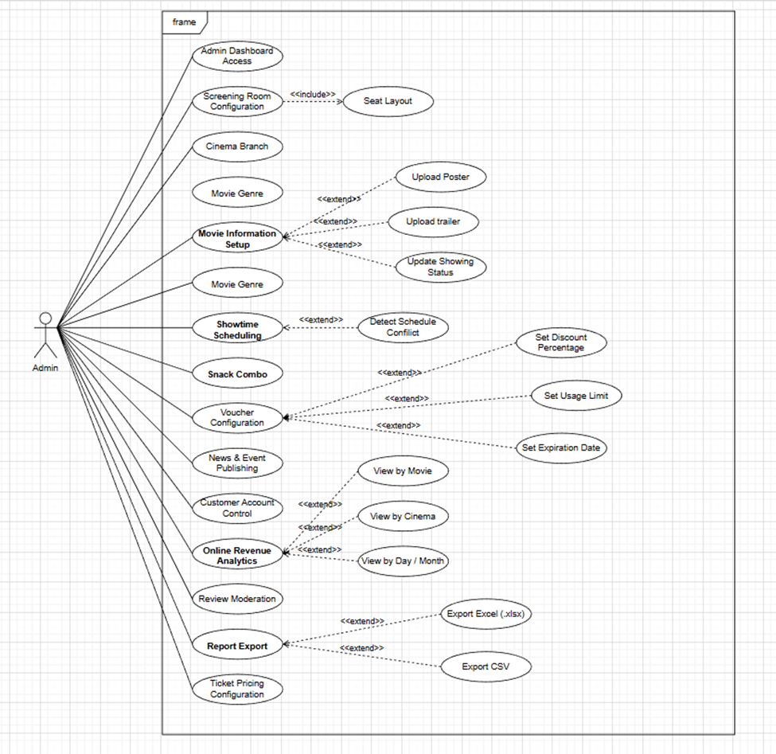
Figure 3. Admin use case diagram

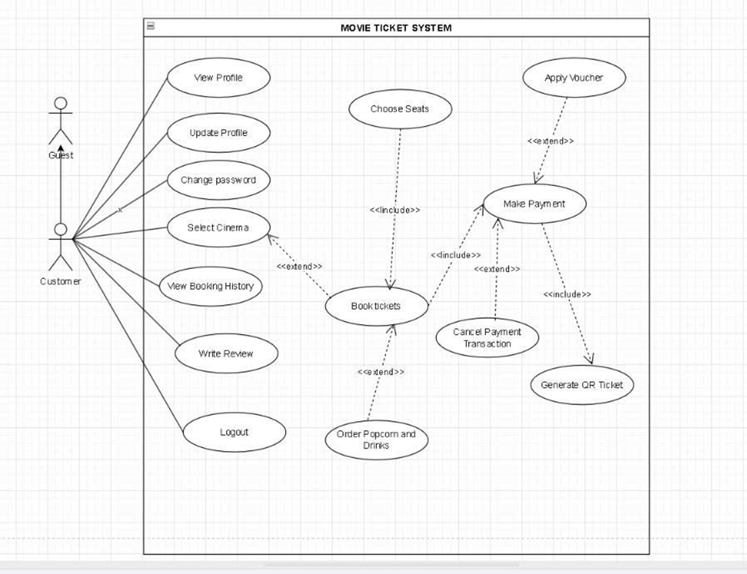
Figure 4. Customer use case diagram

b. Descriptions
This part describes the use cases, you can follow the table form as below]
ID | Feature | Use Case | Use Case Description
UC-01 | Information Lookup | View cinema branches | Filter and view the list of cinema branches by city/province.
UC-02 | Information Lookup | View movie catalog | View the list of 'Now Showing' and 'Coming Soon' movies.
UC-03 | Information Lookup | View movie details | View movie posters, trailers, synopsis, director, cast, and duration.
UC-04 | Information Lookup | Search & filter movies | Quickly search for movies by name or filter by genre and format (2D, 3D).
UC-05 | Information Lookup | Look up showtimes | Check specific showtimes by date, movie, and cinema branch.
UC-06 | Information Lookup | View news & promotions | Read articles about ongoing events and promotional campaigns of the cinema chain.
UC-07 | Information Lookup | View ticket pricing policy | Look up the standard ticket pricing table of the cinema.
UC-08 | Authentication | Register account | Fill in information to create a new member account.
UC-09 | Authentication | Verify account | Confirm the OTP code sent via Email to activate the account.
UC-10 | Authentication | Login | Log into the system using Email and Password.
UC-11 | Authentication | Recover password | Request a new password via Email when forgotten.
UC-12 | Profile Management | View personal profile | View current account information.
UC-13 | Profile Management | Update personal profile | Change name, phone number, and date of birth.
UC-14 | Profile Management | Change password | Update to a new secure password.
UC-15 | Profile Management | View reward points & tier | Track accumulated loyalty points and membership tier.
UC-16 | Authentication | Logout | Safely end the current working session.
UC-17 | Online Booking | Select branch & showtime | Accurately select the desired cinema branch and time slot.
UC-18 | Online Booking | View seating plan | Display the real-time seating map.
UC-19 | Online Booking | Select / Deselect seats | Click to select a seat (the system temporarily locks the seat to prevent double booking).
UC-20 | Online Booking | Book F&B combo | Add food and beverage packages to the booking cart.
UC-21 | Online Booking | Apply voucher | Enter a promotional code to deduct from the total order amount.
UC-22 | Online Booking | Select payment method | Choose to pay via E-wallets (MoMo/VNPAY/ZaloPay) or bank cards.
UC-23 | Online Booking | Process payment | Confirm the transaction with the payment gateway API.
UC-24 | Online Booking | Cancel payment transaction | Cancel the cart before payment and release locked seats.
UC-25 | Online Booking | Receive e-ticket (QR Code) | System generates and displays the electronic ticket code immediately after successful payment.
UC-26 | Transaction & Review | View transaction history | Look up the list of booked tickets and check payment status.
UC-27 | Transaction & Review | Request online refund/cancel | Submit a ticket cancellation request (if allowed by system policy before showtime).
UC-28 | Transaction & Review | Write a review | Rate and write comments for the movie after watching.
UC-29 | Authentication | Login to Admin Dashboard | Access the administrative workspace.
UC-30 | Core Data Management | Update cinema branches | Add new, edit information, or toggle the operational status of cinema branches.
UC-31 | Core Data Management | Configure screening halls | Add new screening halls, configure total seats, and draw seat layout maps (Standard, VIP, Couple seats).
UC-32 | Core Data Management | Update movie genres | Add, edit, or delete genre categories (Action, Comedy, Horror...).
UC-33 | Core Data Management | Update movie catalog | Initialize movie data, upload images/trailers, and update showing status.
UC-34 | Core Data Management | Schedule showtimes | Allocate movies to screening halls and time slots; the system will warn if there are scheduling conflicts.
UC-35 | Business Management | Configure F&B combos | Create new, set prices, and upload images for snack packages.
UC-36 | Business Management | Configure vouchers | Initialize vouchers, set discount percentages, usage limits, and expiration dates.
UC-37 | Business Management | Configure ticket pricing | Set ticket pricing rules (surcharges for holidays, weekends, VIP seats).
UC-38 | Operations | Publish news & events | Post and edit promotional articles displayed on the homepage.
UC-39 | Operations | Moderate customer accounts | View member lists, ban or unban violating accounts.
UC-40 | Operations | Moderate reviews | Approve, hide, or delete negative comments and spam from users.
UC-41 | Statistics & Reports | View online revenue stats | View total revenue charts by movie, cinema branch, or day/month.
UC-42 | Statistics & Reports | Export reports | Extract revenue data into Excel (.xlsx) or CSV files for storage.

2. Overall Functionalities

2.1 Screens Flow
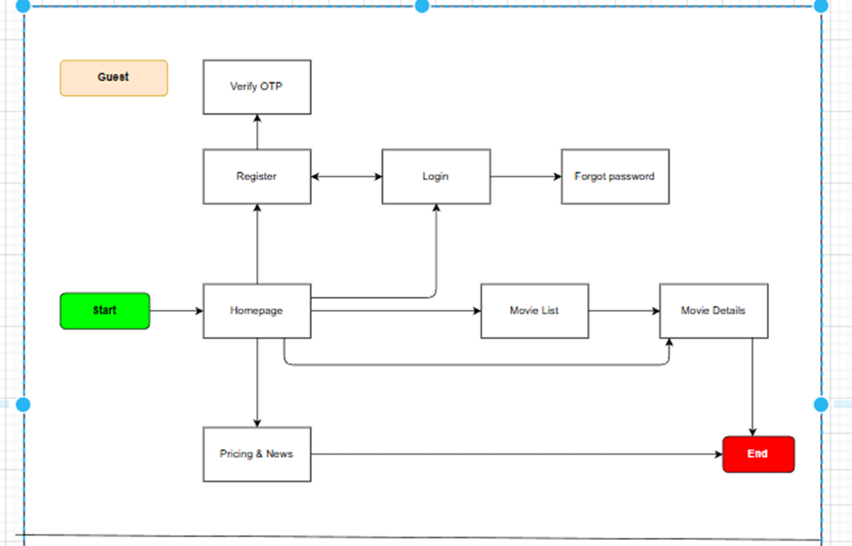
Figure 5. Screen flow Diagram – Guest
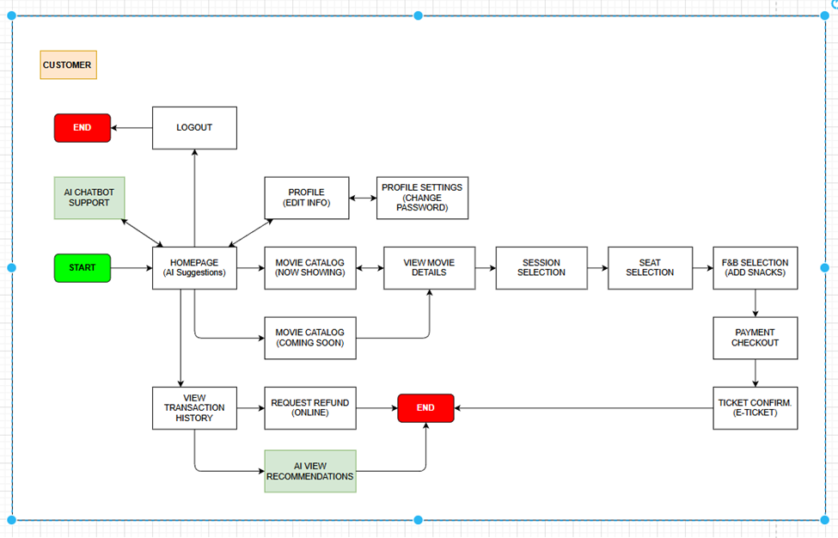
Figure 5. Screen flow Diagram – Customer
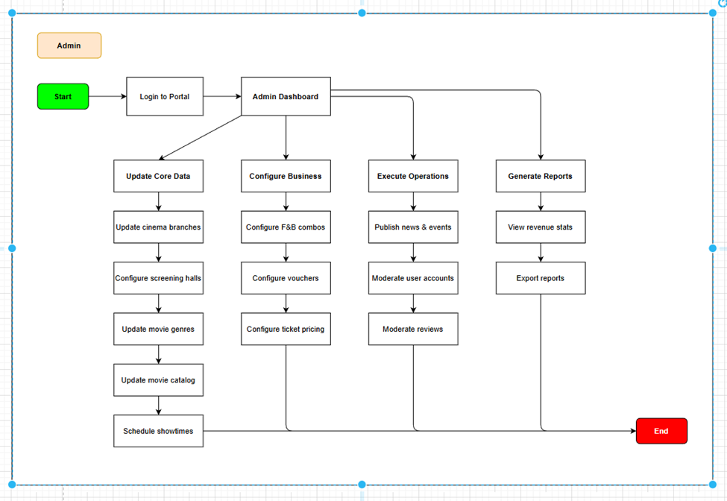
Figure 5. Screen flow Diagram – Admin

2.2 Screen Descriptions
# | Feature | Screen | Detailed Description
1 | Landing Page | Home | Main homepage displaying featured movie banners, now-showing and upcoming movies. Includes navigation menu, search bar, promotional sliders, combo offers, and cinema information. Users can quickly access movie schedules or book tickets directly from the homepage.
2 | Login | Sign In | Authentication screen where users enter email/phone number and password. Supports Google/Facebook/Apple login integration. Includes “Forgot Password”, remember login session, and OTP/email verification if required.
3 | Register | Sign Up | User registration screen with fields such as full name, email, phone number, password, and confirm password. Includes form validation, duplicate account checking, and OTP/email verification for account activation.
4 | Movie List | Movies | Displays movies in grid or list view. Includes filters by genre, language, age rating, and status (Now Showing / Coming Soon). Supports movie search and displays poster, rating, duration, and “Book Now” button.
5 | Movie Detail | Movie Detail | Detailed movie page containing poster, trailer, synopsis, cast, director, genre, duration, age restriction, and user ratings. Users can view schedules by cinema/date and continue to ticket booking.
6 | Showtime | Schedule | Displays available showtimes based on movie, date, and cinema branch. Users can select cinema location, show date, and preferred time slot. The system shows seat availability and sold-out status.
7 | Seat Selection | Seat Map | Interactive real-time seat selection screen. Seats are color-coded for available, booked, VIP, and couple seats. Users can select multiple seats, view live total pricing, and add food & beverage combos.
8 | Cart | Checkout | Shopping cart page displaying selected tickets, seats, showtime details, combos, and total price. Users can edit combo quantity, remove seats, and apply discount vouchers before payment.
9 | Payment | Payment | Secure payment screen supporting multiple payment methods such as bank cards, e-wallets, QR Banking, Apple Pay, and Google Pay. Handles online transaction processing and displays payment status securely.
10 | E-Ticket | QR Ticket | After successful payment, the system generates an electronic ticket with QR Code. Displays movie info, cinema, seats, showtime, and check-in instructions. Users can download PDF tickets or receive them via email.
11 | Booking History | My Tickets | Allows users to view booking history, payment status, and past tickets. Includes search/filter functionality and QR ticket preview. Users may also cancel tickets depending on cinema policy.
12 | Admin Dashboard | Dashboard | Management system for administrators and cinema operators. Includes movie management, showtime scheduling, cinema rooms, users, promotions, and revenue reports. Dashboard displays analytics such as ticket sales and daily/monthly revenue statistics.

2.3 Screen Authorization
Screen | Guest | Customer | Admin
Authentication (Sign Up / Sign In) | X | X | X
Password Recovery | X | X | X
Landing Page | X | X | X
Home Page (Dashboard) |  | X | X
View Cinema Branches | X | X | X
View Movie Listings | X | X | X
View Movie Details | X | X | X
Search & Filter Movies | X | X | X
View Showtimes | X | X | X
View Promotions & News | X | X | X
View Ticket Pricing | X | X | X
View Profile |  | X | X
Update Profile |  | X | X
Change Password |  | X | X
View Reward Points |  | X
Select Cinema & Showtime |  | X
View Seat Layout |  | X
Select / Cancel Seats |  | X
Add Food & Drink Combo |  | X
Apply Voucher |  | X
Select Payment Method |  | X
Make Payment |  | X
Receive QR E-Ticket |  | X
View Booking History |  | X
Request Refund / Cancel Ticket |  | X
Write Movie Review |  | X
Manage Cinema Branches |  |  | X
Manage Screening Rooms |  |  | X
Manage Movie Genres |  |  | X
Manage Movies |  |  | X
Manage Showtimes |  |  | X
Manage Food Combos |  |  | X
Manage Vouchers |  |  | X
Configure Ticket Pricing |  |  | X
Manage News & Events |  |  | X
Manage Customers |  |  | X
Moderate Reviews |  |  | X
View Revenue Statistics |  |  | X
Export Reports |  |  | X
AI Movie Recommendation |  | X
AI Chatbot Support | X | X | X
AI Demand Prediction |  |  | X

2.4 Non-UI Functions
# | Feature | System  Function | Description
1 | Authorization | Function for User | All requests to Candidate, Company and Admin functions are passed through the user authorization middleware.
2 | WebSocket  Connection | Connection | Establishes real-time communication for instant notifications and updates between users and the system.
3 | Push  Notifications | Notify users | Sends real-time notifications about ride status, payment confirmations, promotions, and important updates.

3. System High Level Design

3.1 Database Design

a. Database Schema

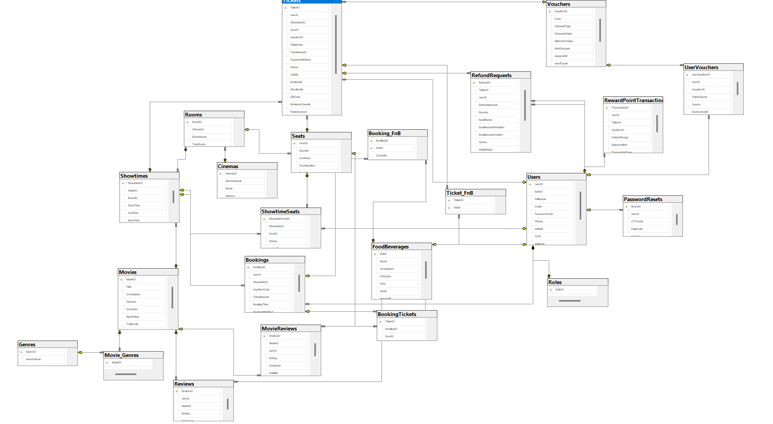

b. Table Descriptions
No | Table | Description
01 | User | Stores account information of Guests promoted to members and Admins, including credentials and contact details. PK: user_id. FK: role_id.
02 | Role | Defines system roles (Admin, Customer) used for authorization. PK: role_id.
03 | Movie | Stores movie information: title, synopsis, duration, age rating, poster, trailer, and showing status. PK: movie_id.
04 | Genre | Movie genre categories (Action, Comedy, Horror...). PK: genre_id.
05 | Movie_Genre | Many-to-many link between movies and genres. PK: (movie_id, genre_id). FK: movie_id, genre_id.
06 | Cinema | Stores cinema branch information: name, address, city/province, status. PK: cinema_id.
07 | Hall | Screening halls belonging to a cinema, with capacity and layout. PK: hall_id. FK: cinema_id.
08 | Seat | Individual seats in a hall with row/column and type (Standard, VIP, Couple). PK: seat_id. FK: hall_id.
09 | Showtime | A scheduled screening of a movie in a hall at a time. PK: showtime_id. FK: movie_id, hall_id.
10 | Showtime_Seat | Per-showtime seat state (available, held, booked) and price. PK: showtime_seat_id. FK: showtime_id, seat_id.
11 | Booking | A customer order created at checkout, holding total amount and status. PK: booking_id. FK: user_id, showtime_id, voucher_id.
12 | Booking_Seat | Seats included in a booking. PK: booking_seat_id. FK: booking_id, showtime_seat_id.
13 | Combo | F&B combo packages with name, price, and image. PK: combo_id.
14 | Booking_Combo | Combos and quantities attached to a booking. PK: booking_combo_id. FK: booking_id, combo_id.
15 | Voucher | Promotional codes with discount value, usage limit, and validity period. PK: voucher_id.
16 | Payment | Payment transaction for a booking with gateway, amount, and status. PK: payment_id. FK: booking_id.
17 | Ticket | E-ticket generated after successful payment, with QR code and check-in status. PK: ticket_id. FK: booking_seat_id.
18 | Review | Customer rating and comment for a watched movie. PK: review_id. FK: user_id, movie_id.
19 | News | Promotional articles and events shown on the homepage. PK: news_id. FK: author_id.
20 | Reward_Point | Loyalty point ledger and membership tier per customer. PK: reward_id. FK: user_id.
21 | Pricing_Rule | Ticket pricing rules and surcharges (holiday, weekend, seat type). PK: rule_id.

3.2 Code Packages
Package descriptions
No | Package | Description
01 | authentication | Handles registration, OTP verification, login/logout, password recovery, JWT issuing, and role-based authorization middleware.
02 | profile | Manages customer profile information, password change, reward points, and membership tier.
03 | movie | CRUD for movies, genres, and the movie–genre relationship; serves catalog, detail, and search/filter queries.
04 | cinema | CRUD for cinema branches, halls, and seat layouts.
05 | showtime | Schedules showtimes, detects hall/time conflicts, and exposes showtime lookup by movie, date, and branch.
06 | booking | Manages the booking cart, real-time seat hold/release via WebSocket, and booking lifecycle (pending → paid → cancelled).
07 | payment | Integrates payment gateways (MoMo/VNPAY/ZaloPay, bank cards), handles callbacks/IPN, and records transactions.
08 | ticket | Generates QR e-tickets, sends them by email, and handles check-in validation.
09 | fnb | CRUD for F&B combos and combo selection at checkout.
10 | voucher | Manages vouchers and validates/applies discount codes during checkout.
11 | review | Manages customer reviews and admin moderation (approve, hide, delete).
12 | news | CRUD for promotional news and events.
13 | report | Aggregates revenue statistics and exports reports to Excel/CSV.
14 | notification | Builds and dispatches push notifications and emails.
15 | ai | Movie recommendation, support chatbot, and demand-prediction services.

II. Requirement Specifications

1. Authentication

1.1 UC-08_Register

a. Functionalities
UC ID and Name: | UC08 – Register Account
Created By: | Huỳnh Thị Thúy Kiều | Date Created: | 30/05/2026
Primary Actor: | Guest | Secondary Actors: | Email Service
Trigger: | Guest clicks the “Register” button on the website.
Description: | This use case allows a guest to create a new customer account by providing personal information. After registration, the system sends an OTP verification code to the user's email address to activate the account.
Preconditions: | PRE-1: The user has access to the registration page.  PRE-2: The email address used for registration does not already exist in the system.  PRE-3: The email service is available.
Postconditions: | POST-1: A new customer account is created.  POST-2: The password is encrypted using MD5 before being stored in the database.  POST-3: An OTP verification code is sent to the user's email.  POST-4: The account status is set to "Pending Verification".
Normal Flow: | 8.0.1 User selects the Register option.  8.0.2 System displays the registration form.  8.0.3 User enters full name, email address, phone number, date of birth, password, and confirm password.  8.0.4 User submits the registration form.  8.0.5 System validates all input data.  8.0.6 System checks whether the email already exists.  8.0.7 System encrypts the password using MD5.  8.0.8 System creates a new account with Pending Verification status.  8.0.9 System generates an OTP verification code.  8.0.10 System sends the OTP code to the user's email.  8.0.11 System displays a message requesting email verification.
Alternative Flows: | 8.1 Email already exists  8.1.1 At step 8.0.6, the system detects that the email is already registered.  8.1.2 System displays an error message.  8.1.3 User enters another email address.  8.1.4 Return to step 8.0.3.  8.2 User resends OTP  8.2.1 User requests a new OTP.  8.2.2 System generates a new OTP.  8.2.3 System sends the new OTP to the registered email.
Exceptions: | 8.0.E1 Invalid input format  At step 8.0.5, one or more fields are invalid.  System highlights the invalid fields and requests correction.  8.0.E2 Email service unavailable  At step 8.0.10, the email server cannot send OTP.  System displays an error message and logs the incident.  8.0.E3 Database connection failure  At step 8.0.8, the database is unavailable.  System rolls back the registration transaction and displays an error message.
Priority: | High (Medium, Low), Must Have (Should Have, Could Have),..
Frequency of Use: | High (expected hundreds of registrations per day)
Business Rules: | BR01 – Password Encoding  BR02 – Unique Email Address  BR03 – OTP Verification Required
Other Information: | Passwords must never be stored in plain text.  OTP expires after 5 minutes.  If registration fails before account creation is completed, no user data shall be persisted.
Assumptions: | The user owns the provided email address.  The email service is functioning normally.

b. Business Rules
ID | Business Rule | Business Rule Description
BR-REG-01 | Password Encoding | User passwords must be encoded using MD5 hashing before storage in the database.
BR-REG-02 | Unique Email Address | Each email address can only be registered once in the system.
BR-REG-03 | OTP Verification | Users must verify their email address using OTP before account activation.
BR-REG-04 | OTP Expiration | OTP verification codes expire after 5 minutes.

UC09 – Verify Account
UC ID and Name: | UC09 – Verify Account
Created By: | Nguyen Minh Huy | Date Created: | 30/05/2026
Primary Actor: | Guest | Secondary Actors: | Email Service
Trigger: | The user enters the OTP verification code received via email.
Description: | This use case allows a newly registered user to verify their email address using an OTP code. Successful verification activates the account and allows the user to log in.
Preconditions: | PRE-1: The user has successfully registered an account.  PRE-2: The account status is "Pending Verification".  PRE-3: A valid OTP has been generated and sent to the user's email.
Postconditions: | POST-1: The account status is updated to "Active".  POST-2: The user can access all customer authentication features.  POST-3: The OTP code becomes invalid after successful verification.
Normal Flow: | 9.0.1 User opens the verification page.  9.0.2 System displays the OTP verification form.  9.0.3 User enters the OTP code.  9.0.4 User submits the verification request.  9.0.5 System validates the OTP code.  9.0.6 System verifies that the OTP has not expired.  9.0.7 System activates the user account.  9.0.8 System invalidates the OTP code.  9.0.9 System displays a verification success message.
Alternative Flows: | 9.1 Resend OTP  9.1.1 User selects "Resend OTP".  9.1.2 System generates a new OTP code.  9.1.3 System sends the new OTP to the registered email.  9.1.4 User continues verification.
Exceptions: | 9.0.E1 Invalid OTP  Occurs at step 9.0.5.  System displays an error message.  9.0.E2 Expired OTP  Occurs at step 9.0.6.  System requests the user to generate a new OTP.  9.0.E3 Account Already Verified  Occurs at step 9.0.7.  System informs the user that the account is already active.
Priority: | High (Medium, Low), Must Have (Should Have, Could Have),..
Frequency of Use: | High (expected hundreds of registrations per day)
Business Rules: | BR-VER-01  BR-VER-02  BR-VER-03
Other Information: | OTP codes must be stored securely.  Maximum OTP attempts allowed: 5.  Expired OTPs are automatically removed.
Assumptions: | The user has access to the registered email address.  The email service is functioning normally.

b. Business Rules
ID | Business Rule | Business Rule Description
BR-VER-01 | OTP Validation | OTP must exactly match the generated code.
BR-VER-02 | OTP Expiration | OTP expires after 5 minutes.
BR-VER-03 | Activation Requirement | Users cannot log in until email verification is completed.

UC10 – Login
UC ID and Name: | UC10 – Login
Created By: | Nguyễn Hữu Tấn Đạt | Date Created: | 30/05/2026
Primary Actor: | Customer | Secondary Actors: | Authentication Service
Trigger: | The user selects the Login option and submits credentials.
Description: | This use case allows a registered customer to authenticate and access the online cinema booking system using an email address and password.
Preconditions: | PRE-1: The customer account exists.  PRE-2: The account has been verified.  PRE-3: The account is not locked or banned.
Postconditions: | POST-1: User authentication is completed successfully.  POST-2: JWT access token is generated.  POST-3: User session is established.  POST-4: Customer is redirected to the homepage.
Normal Flow: | 10.0.1 User clicks the Login button.  10.0.2 System displays the login page.  10.0.3 User enters email and password.  10.0.4 User submits login information.  10.0.5 System validates input data.  10.0.6 System retrieves user account information.  10.0.7 System compares the encrypted password with the stored password.  10.0.8 System authenticates the user.  10.0.9 System generates JWT access token.  10.0.10 System creates a login session.  10.0.11 System redirects the user to the homepage.
Alternative Flows: | 10.1 Remember Me  10.1.1 User selects the "Remember Me" option.  10.1.2 System extends session expiration time.  10.1.3 Continue at step 10.0.11.
Exceptions: | 10.0.E1 Invalid Email  Occurs at step 10.0.6.  System displays "Account not found."  10.0.E2 Incorrect Password  Occurs at step 10.0.7.  System displays "Incorrect password."  10.0.E3 Account Not Verified  Occurs at step 10.0.8.  System requests email verification.  10.0.E4 Account Locked  Occurs at step 10.0.8.  System denies login access.  10.0.E5 Database Failure  Occurs at step 10.0.6.  System displays an error message.
Priority: | High (Medium, Low), Must Have (Should Have, Could Have),..
Frequency of Use: | Very High (thousands of logins per day)
Business Rules: | BR-LOG-01  BR-LOG-02  BR-LOG-03  BR-LOG-04
Other Information: | JWT tokens are used for authentication.  Inactive sessions expire automatically.  The system logs login history for auditing purposes.
Assumptions: | The user remembers their credentials.  The authentication server is available.  Internet connectivity is stable.

b. Business Rules
ID | Business Rule | Business Rule Description
BR-LOG-01 | Password Verification | Entered password must match the stored MD5-hashed password.
BR-LOG-02 | Account Verification | Only verified accounts are allowed to log in.
BR-LOG-03 | JWT Authentication | JWT tokens must be generated after successful authentication.
BR-LOG-04 | Account Status Validation | Locked or banned accounts cannot log in.

UC10A – Login with Google
UC ID and Name: | UC10A – Login with Google
Created By: | Nguyễn Hữu Tấn Đạt | Date Created: | 30/05/2026
Primary Actor: | Guest / Customer | Secondary Actors: | Google Authentication Service
Trigger: | The user clicks the "Login with Google" button.
Description: | This use case allows a user to authenticate using their Google account instead of entering an email and password. If the Google account does not already exist in the system, a new customer account is automatically created.
Preconditions: | PRE-1: The Google Authentication Service is available.  PRE-2: The user has a valid Google account.  PRE-3: The system has been configured with Google OAuth credentials.
Postconditions: | POST-1: User authentication is completed successfully.  POST-2: A JWT access token is generated.  POST-3: A new account is created if the Google account does not already exist.  POST-4: User is redirected to the homepage.
Normal Flow: | 10A.0.1 User clicks "Login with Google".  10A.0.2 System redirects the user to Google's authentication page.  10A.0.3 User selects a Google account.  10A.0.4 Google authenticates the user.  10A.0.5 Google sends user information to the system.  10A.0.6 System checks whether the email already exists.  10A.0.7 System creates a new account if necessary.  10A.0.8 System generates a JWT access token.  10A.0.9 System creates a login session.  10A.0.10 System redirects the user to the homepage.
Alternative Flows: | 10A.1 Existing Account  10A.1.1 At step 10A.0.6, the account already exists.  10A.1.2 System logs the user in directly.  10A.1.3 Continue at step 10A.0.8.
Exceptions: | 10A.0.E1 Google Authentication Failed  Occurs at step 10A.0.4.  System displays an authentication error message.  10A.0.E2 User Cancels Authentication  Occurs at step 10A.0.3.  System redirects the user back to the login page.  10A.0.E3 Google Service Unavailable  Occurs at step 10A.0.4.  System displays a service unavailable message.
Priority: | High (Medium, Low), Must Have (Should Have, Could Have),..
Frequency of Use: | High (expected hundreds of registrations per day)
Business Rules: | BR-GGL-01  BR-GGL-02  BR-GGL-03
Other Information: | OAuth 2.0 protocol must be used.  JWT authentication must be generated after successful login.
Assumptions: | The user has internet access.  Google OAuth service is operational.

b. Business Rules
ID | Business Rule | Business Rule Description
BR-GGL-01 | OAuth Authentication | Login must be performed using Google OAuth 2.0.
BR-GGL-02 | Automatic Registration | A customer account shall be created automatically if it does not already exist.
BR-GGL-03 | JWT Generation | A JWT token must be issued after successful authentication.

UC11 – Forgot Password
UC ID and Name: | UC11 – Forgot Password
Created By: | Bùi Thùy Dung | Date Created: | 30/05/2026
Primary Actor: | Guest | Secondary Actors: | Email Service
Trigger: | The user clicks the "Forgot Password" link.
Description: | This use case allows a registered user to reset their password by receiving a password reset link or OTP code through email.
Preconditions: | PRE-1: The user account exists.  PRE-2: The registered email address is accessible.  PRE-3: Email service is available.
Postconditions: | POST-1: User receives a password reset email.  POST-2: User successfully resets the password.  POST-3: The new password is encrypted using MD5 before storage.
Normal Flow: | 11.0.1 User clicks "Forgot Password".  11.0.2 System displays the password recovery form.  11.0.3 User enters the registered email address.  11.0.4 User submits the request.  11.0.5 System validates the email address.  11.0.6 System generates a reset token or OTP.  11.0.7 System sends the reset information via email.  11.0.8 User opens the reset link or enters OTP.  11.0.9 User enters a new password.  11.0.10 User confirms the new password.  11.0.11 System validates password requirements.  11.0.12 System encrypts the password using MD5.  11.0.13 System updates the password.  11.0.14 System displays a success message.
Alternative Flows: | 11.1 Resend Reset Email  11.1.1 User requests another reset email.  11.1.2 System generates a new reset token.  11.1.3 System sends a new email.
Exceptions: | 11.0.E1 Email Not Found  Occurs at step 11.0.5.  System informs the user that no account exists.  11.0.E2 Invalid Reset Token  Occurs at step 11.0.8.  System requests a new reset request.  11.0.E3 Expired Reset Token  Occurs at step 11.0.8.  System requires a new password recovery request.  11.0.E4 Email Service Failure  Occurs at step 11.0.7.  System displays an error message.
Priority: | High (Medium, Low), Must Have (Should Have, Could Have),..
Frequency of Use: | Medium
Business Rules: | BR-FGT-01  BR-FGT-02  BR-FGT-03  BR-FGT-04
Other Information: | Password reset tokens expire after 15 minutes.  All password reset attempts must be logged.
Assumptions: | The user has access to the registered email.  The email service is functioning properly.

b. Business Rules
ID | Business Rule | Business Rule Description
BR-FGT-01 | Registered Email Validation | Password reset is only available for registered email addresses.
BR-FGT-02 | Password Encryption | New passwords must be stored using MD5 hashing.
BR-FGT-03 | Reset Token Expiration | Password reset tokens expire after 15 minutes.
BR-FGT-04 | Password Policy | New passwords must satisfy the password policy requirements.

UC12 – View Profile
UC ID and Name: | UC12 – View Profile
Created By: | Bùi Thùy Dung | Date Created: | 30/05/2026
Primary Actor: | Customer | Secondary Actors: | Database System
Trigger: | The user selects the Login option and submits credentials.
Description: | This use case allows a logged-in customer to view their personal account information, including profile details, membership status, reward points, and account settings.
Preconditions: | PRE-1: Customer is authenticated.  PRE-2: Customer account is active.  PRE-3: Customer profile information exists.
Postconditions: | POST-1: Customer profile information is displayed successfully.  POST-2: No data is modified.
Normal Flow: | 12.0.1 Customer selects "My Profile".  12.0.2 System verifies authentication status.  12.0.3 System retrieves customer profile information.  12.0.4 System retrieves membership information.  12.0.5 System retrieves reward point information.  12.0.6 System displays profile details.  12.0.7 Customer reviews profile information.
Alternative Flows: | 12.1 View Profile on Mobile Device  12.1.1 Customer accesses profile through a mobile browser.  12.1.2 System displays a responsive profile interface.  12.1.3 Continue at step 12.0.7.
Exceptions: | 10.0.E1 Invalid Email  12.0.E1 Session Expired  Occurs at step 12.0.2.  System redirects the customer to the login page.  12.0.E2 Profile Not Found  Occurs at step 12.0.3.  System displays an error message.  12.0.E3 Database Failure  Occurs at step 12.0.3.  System displays a system error notification.
Priority: | High (Medium, Low), Must Have (Should Have, Could Have),..
Frequency of Use: | High
Business Rules: | BR-PRO-01  BR-PRO-02  BR-PRO-03
Other Information: | Profile information shall be loaded within 3 seconds.  Sensitive information must not be exposed.  System shall support responsive design.
Assumptions: | Customer account information exists.  Database service is available.

b. Business Rules
ID | Business Rule | Business Rule Description
BR-PRO-01 | Authentication Required | Only authenticated customers can access profile information.
BR-PRO-02 | Data Privacy | Sensitive information must be protected and not fully displayed.
BR-PRO-03 | Read-Only Access | Viewing profile information shall not modify any data.

UC13 – Edit Profile
UC ID and Name: | UC13 – Edit Profile
Created By: | Bùi Thùy Dung | Date Created: | 30/05/2026
Primary Actor: | Customer | Secondary Actors: | Database System
Trigger: | Customer selects the “Edit Profile” option.
Description: | This use case allows an authenticated customer to update personal profile information such as full name, phone number, date of birth, and address.
Preconditions: | PRE-1: Customer has successfully logged into the system.  PRE-2: Customer account is active.  PRE-3: Customer profile exists.
Postconditions: | POST-1: Profile information is updated successfully.  POST-2: Updated information is stored in the database.  POST-3: Customer can view the updated profile immediately.
Normal Flow: | 13.0.1 Customer selects Edit Profile.  13.0.2 System displays editable profile information.  13.0.3 Customer updates personal information.  13.0.4 Customer submits changes.  13.0.5 System validates input data.  13.0.6 System updates profile information.  13.0.7 System saves changes to the database.  13.0.8 System displays a success message.
Alternative Flows: | 13.1 Partial Update  13.1.1 Customer updates only selected fields.  13.1.2 System validates modified fields.  13.1.3 Continue at step 13.0.6.
Exceptions: | 13.0.E1 Invalid Phone Number  Occurs at step 13.0.5.  System displays validation error.  13.0.E2 Invalid Date of Birth  Occurs at step 13.0.5.  System requests valid input.  13.0.E3 Database Failure  Occurs at step 13.0.7.  System rolls back all changes.
Priority: | High (Medium, Low), Must Have (Should Have, Could Have),..
Frequency of Use: | High (expected hundreds of registrations per day)
Business Rules: | BR-EP-01  BR-EP-02  BR-EP-03
Other Information: | Profile updates must be reflected immediately.  Database transactions must ensure consistency.
Assumptions: | Customer provides accurate information.

b. Business Rules
ID | Business Rule | Business Rule Description
BR-EP-01 | Data Validation | Updated information must pass validation rules.
BR-EP-02 | Active Account | Only active accounts may edit profiles.
BR-EP-03 | Audit Logging | Profile modifications must be logged.

UC14 – Change Password
UC ID and Name: | UC14 – Change Password
Created By: | Nguyen Minh Huy | Date Created: | 30/05/2026
Primary Actor: | Customer | Secondary Actors: | Authentication Service
Trigger: | Customer selects the “Change Password” option.
Description: | This use case allows a logged-in customer to replace the current password with a new password.
Preconditions: | PRE-1: Customer is authenticated.  PRE-2: Customer account is active.  PRE-3: Customer knows the current password.
Postconditions: | POST-1: Password is successfully updated.  POST-2: New password is stored using MD5 hashing.  POST-3: Previous sessions may be invalidated.
Normal Flow: | 14.0.1 Customer selects Change Password.  14.0.2 System displays password change form.  14.0.3 Customer enters current password.  14.0.4 Customer enters new password.  14.0.5 Customer confirms new password.  14.0.6 Customer submits request.  14.0.7 System validates current password.  14.0.8 System validates password policy.  14.0.9 System encrypts the new password.  14.0.10 System updates password.  14.0.11 System displays success message.
Alternative Flows: | 14.1 Force Re-login  14.1.1 System terminates all active sessions.  14.1.2 Customer must log in again.
Exceptions: | 14.0.E1 Incorrect Current Password  Occurs at step 14.0.7.  System rejects the request.  14.0.E2 Password Policy Violation  Occurs at step 14.0.8.  System requests another password.  14.0.E3 Database Failure  Occurs at step 14.0.10.  System rolls back the transaction.
Priority: | High (Medium, Low), Must Have (Should Have, Could Have),..
Frequency of Use: | Medium
Business Rules: | BR-CP-01  BR-CP-02  BR-CP-03  BR-CP-04
Other Information: | Passwords must never be stored in plain text.  Password changes should be logged.
Assumptions: | Customer remembers current password.

b. Business Rules
ID | Business Rule | Business Rule Description
BR-CP-01 | Current Password Verification | Current password must be verified before updating
BR-CP-02 | Password Encoding | New password must be stored using MD5 hashing.
BR-CP-03 | Password Policy | Password must meet security requirements.
BR-CP-04 | Session Security | Existing sessions may be invalidated after password change.

UC15 – Change Avatar
UC ID and Name: | UC15 – Change Avatar
Created By: | Huỳnh Thị Thúy Kiều | Date Created: | 30/05/2026
Primary Actor: | Customer | Secondary Actors: | File Storage Service
Trigger: | Customer selects the “Change Avatar” option.
Description: | This use case allows a customer to upload and update a profile picture.
Preconditions: | PRE-1: Customer is authenticated.  PRE-2: Customer account is active.  PRE-3: File storage service is available.
Postconditions: | POST-1: Avatar image is updated.  POST-2: Avatar URL is stored in the database.  POST-3: New avatar is displayed throughout the system.
Normal Flow: | 15.0.1 Customer selects Change Avatar.  15.0.2 System displays upload interface.  15.0.3 Customer selects an image file.  15.0.4 Customer uploads the image.  15.0.5 System validates image format and size.  15.0.6 System stores image file.  15.0.7 System updates avatar URL.  15.0.8 System displays updated avatar.
Alternative Flows: | 15.1 Remove Avatar  15.1.1 Customer chooses Remove Avatar.  15.1.2 System restores default avatar.
Exceptions: | 15.0.E1 Unsupported File Format Occurs at step  15.0.5. System rejects the upload.  15.0.E2 File Size Exceeded Occurs at step  15.0.5. System requests a smaller image.  15.0.E3 Storage Service Failure  Occurs at step 15.0.6.  System displays upload failure message.
Priority: | Medium – Should Have
Frequency of Use: | Medium
Business Rules: | BR-CP-01  BR-CP-02  BR-CP-03
Other Information: | Supported formats include JPG, PNG, and WEBP.  Maximum file size is 5 MB.
Assumptions: | Customer uploads a valid image file.

b. Business Rules
ID | Business Rule | Business Rule Description
BR-AV-01 | File Type Validation | Only JPG, PNG, and WEBP formats are allowed.
BR-AV-02 | File Size Limitation | Uploaded image must not exceed 5 MB.
BR-AV-03 | Secure File Storage | Avatar images must be stored securely.

UC16 – Logout
UC ID and Name: | UC16 – Logout
Created By: | Huỳnh Thị Thúy Kiều | Date Created: | 30/05/2026
Primary Actor: | Customer | Secondary Actors: | Authentication Service
Trigger: | Customer clicks the Logout button.
Description: | This use case allows a customer to terminate the current authenticated session securely.
Preconditions: | PRE-1: Customer is authenticated.  PRE-2: Active session exists.
Postconditions: | POST-1: Session is terminated.  POST-2: JWT token becomes invalid.  POST-3: Customer is redirected to the homepage or login page.
Normal Flow: | 16.0.1 Customer clicks Logout.  16.0.2 System verifies active session.  16.0.3 System invalidates JWT token.  16.0.4 System destroys session data.  16.0.5 System redirects customer.  16.0.6 System displays logout confirmation.
Alternative Flows: | 16.1 Automatic Logout  16.1.1 Session timeout occurs.  16.1.2 System automatically logs out the customer.
Exceptions: | 16.0.E1 Session Not Found Occurs at step  16.0.2. System redirects customer to login page.  16.0.E2 Server Failure  Occurs during logout process.  System clears local authentication data.
Priority: | High – Must Have
Frequency of Use: | Very High
Business Rules: | BR-LO-01  BR-LO-02
Other Information: | Logout must invalidate all authentication tokens.  No user data shall remain accessible after logout.
Assumptions: | Authentication services are available.

b. Business Rules
ID | Business Rule | Business Rule Description
BR-LO-01 | Session Termination | Logout must terminate the active session.
BR-LO-02 | Token Invalidation | JWT token must become invalid after logout.

UC17 – Select Branch & Showtime
UC ID and Name: | UC17 – Select Branch & Showtime
Created By: | Nguyen Minh Huy | Date Created: | 16/06/2026
Customer | Customer | Secondary Actors: | Database System
Trigger: | The customer selects a specific movie and clicks the "Book Ticket" (or "Buy Ticket") option.
Description: | This use case allows a customer to choose their preferred City/Province, specific Cinema Branch, Date, and Time slot for the selected movie before proceeding to seat selection, ordering concessions (popcorn/drinks), and applying vouchers.
Preconditions: | PRE-1: The system is operational and connected to the database.  PRE-2: The customer has successfully selected a specific movie.  PRE-3: Showtime schedules for the cinema branches have been updated and are active in the database.
Postconditions: | POST-1: The selected branch, date, and showtime are successfully captured and recorded in the current session.  POST-2: The system automatically redirects the customer to the "Seat Selection" screen for that specific showtime.
Normal Flow: | 17.0.1 System displays a list of available Cities/Provinces where cinemas are located.  17.0.2 Customer selects the desired City/Province.  17.0.3 System displays a list of cinema branches available in that selected region.  17.0.4 Customer selects a specific cinema branch.  17.0.5 System displays the list of screening Dates and available Showtimes (along with formats like 2D/3D, Subtitled/Dubbed) for the selected movie at that branch.  17.0.6 Customer selects the preferred Date and Showtime slot.  17.0.7 System verifies the current availability of the showtime (e.g., checks if seats are still available and if the booking window is open).  17.0.8 System redirects the Customer to the next phase (Seat Selection screen).
Alternative Flows: | 17.1 Switch Movie Directly on the Showtime Screen  17.1.1 Customer clicks on the movie selection dropdown menu.  17.1.2 System reloads and refreshes the schedule based on the newly selected movie.  17.1.3 Continue at step 17.0.2.  17.2 Auto-detect Nearest Cinema Branch via Location Services  17.2.1 Customer grants location access (GPS) permissions to the app or browser.  17.2.2 System automatically bumps the closest cinema branch to the top of the list.  17.2.3 Continue at step 17.0.5.
Exceptions: | 17.0.E1 No Available Showtimes (At step 17.0.5): No active screening schedules exist for the movie at the selected branch/date. System displays the message: "There are currently no showtimes available for this movie at this branch. Please select another date or cinema."  17.0.E2 Showtime Locked / Sold Out (At step 17.0.7): The chosen slot runs out of seats or is locked by the system right before submission. System displays an alert and prompts the user to pick a different showtime.  17.0.E3 Database Connection Failure (At step 17.0.3 or 17.0.5): Failed to retrieve cinema locations or timetable schedules. System displays a temporary network error or system maintenance notice.
Priority: | High /Must Have
Frequency of Use: | High (expected hundreds of registrations per day)
Business Rules: | BR-SHOW-01, BR-SHOW-02, BR-SHOW-03
Other Information: | Showtime schedules must be retrieved and fully loaded within 2 seconds. The interface must dynamically highlight movie format tags (2D/3D, Dubbed/Subtitled) to avoid accidental user selection errors. System must support responsive layouts across devices.
Assumptions: | Cinema scheduling records exist. Database services are stable and reachable.

b. Business Rules
ID | Business Rule | Business Rule Description
BR-SHOW-01 | Showtime Booking Cutoff | The system must not display or allow customers to select showtimes that have already passed, or slots that are scheduled to start in less than 10 minutes (to ensure sufficient time for transaction processing and theater boarding).
BR-SHOW-02 | Real-time Sold-out Sync | A showtime slot is only marked as selectable if its remaining available seat count is greater than zero ($> 0$). If a room becomes fully booked, the showtime must display a "Sold Out" tag and be immediately disabled.
BR-SHOW-03 | Ticket Surcharge Transparency | Screening slots with premium formats (e.g., 3D, IMAX, VIP lounges) or slots scheduled during high-demand periods (Weekends, Public Holidays) must be clearly labeled with a pricing indicator, as their base ticket rates differ from standard 2D weekdays.

UC18 – View Seat Map
UC ID and Name: | UC18 – View Seat Map
Created By: | Nguyen Minh Huy | Date Created: | 16/06/2026
Customer | Customer | Secondary Actors: | Database System, Real-time Sync Service
Trigger: | Customer successfully selects a specific showtime slot in UC17.
Description: | This use case allows the customer to view the real-time layout of the theater room for their selected showtime. It displays seat availability dynamically, letting the user select their desired seats before moving on to concessions and voucher applications.
Preconditions: | PRE-1: Customer has successfully completed UC17 (Select Branch & Showtime).  PRE-2: The theater room layout configuration exists and is active in the database.
Postconditions: | POST-1: The chosen seats are temporarily locked for the customer.  POST-2: The system successfully passes the selected seat data and redirects the user to the "Concessions Selection" (Popcorn & Drinks) screen.
Normal Flow: | 18.0.1 System retrieves the specific theater room configuration and real-time seat statuses for the selected showtime.  18.0.2 System displays the visual seat map layout (including Row/Column indicators, Screen positioning, and Exit doors).  18.0.3 System displays real-time status color-coding for each seat (Available, Booked, or Processing/Held by others) and seat types (Standard, VIP, Sweetbox).  18.0.4 Customer views the map and clicks on their preferred available seat(s).  18.0.5 System verifies seat availability and temporarily locks the selected seat(s) for the current user session.  18.0.6 System updates the visual status of the selected seats to "Your Selection" and initiates a checkout countdown timer.  18.0.7 Customer reviews the total seat price summary and clicks "Continue".
Alternative Flows: | 18.1 Dynamic Real-time Map Refresh  18.1.1 While the Customer is viewing the seat map, another user books a seat.  18.1.2 Real-time Sync Service pushes the update and dynamically changes that seat's status to "Booked" on the current user's screen without reloading the page.  18.1.3 Continue at step 18.0.4.  18.2 Deselecting a Seat  18.2.1 Customer clicks on a seat they have already selected.  18.2.2 System releases the temporary lock on that seat and changes its status back to "Available".  18.2.3 System recalculates and updates the total price summary.
Exceptions: | 18.0.E1 Race Condition / Seat Just Taken (At step 18.0.5): Another user managed to lock or book the identical seat milliseconds before the Customer clicked it. System displays an alert: "This seat was just selected by another user. Please choose a different seat." and refreshes that specific seat's status.  18.0.E2 Reservation Timeout (At step 18.0.6): The countdown timer expires before the customer proceeds. System automatically releases the locked seats, returns them to "Available" status, and alerts the user to re-select.  18.0.E3 Room Layout Load Failure (At step 18.0.1): System fails to fetch the room data. System displays an error message and redirects the user back to the Showtime selection screen.
Priority: | High /Must Have
Frequency of Use: | High
Business Rules: | BR-SEAT-01, BR-SEAT-02, BR-SEAT-03
Other Information: | The seat map interface must be fully optimized for touch controls on mobile devices (pinch-to-zoom support). Real-time synchronization lag must be under 1 second using WebSockets or SSE (Server-Sent Events).
Assumptions: | The customer understands that seats are only held temporarily and are not officially purchased until successful payment processing.

b. Business Rules
ID | Business Rule | Business Rule Description
BR-SEAT-01 | Temporary Seat Lock Timer | Once a customer selects a seat, the system must temporarily hold/lock it for exactly 5 minutes (300 seconds). If the customer does not proceed or pay within this window, the lock expires automatically, and the seat becomes available to the public again.
BR-SEAT-02 | Maximum Seat Limit per Order | To prevent commercial scalping or hoarding, a single customer account or session is restricted to selecting a maximum of 8 seats per single booking transaction.
BR-SEAT-03 | Seat Category Tier Pricing | Ticket pricing logic must dynamically adjust based on the seat category selected from the map:  - Standard Seats: Base Price.  - VIP Seats: Base Price + 15% surcharge.  - Sweetbox (Couple) Seats: Sold strictly in pairs (multiples of 2) with a unique flat premium rate.

UC19 – Select / Deselect Seat
UC ID and Name: | UC19 – Select / Deselect Seat
Created By: | Nguyen Minh Huy | Date Created: | 16/06/2026
Customer | Customer | Secondary Actors: | Database System, Real-time Sync Service
Trigger: | Customer clicks on a seat icon on the visual seat map interface (from UC18).
Description: | This use case handles the core processing logic when a customer interacts with the seat layout. It manages the temporary locking mechanism when a seat is chosen to prevent double-booking, as well as the instant unlocking mechanism when a customer unchecks a seat.
Preconditions: | PRE-1: Customer is currently interacting with the real-time seat map interface (UC18).  PRE-2: The booking session countdown timer is active and has not expired.
Postconditions: | POST-1: The target seat's status is updated immediately in the distributed cache/database system.  POST-2: Total ticket cost and selected seat tallies are dynamically recalculated and refreshed on the user interface.
Normal Flow: | 19.0.1 Customer clicks on an "Available" seat on the screen layout.  19.0.2 System catches the request and checks the real-time database state to verify the seat is still completely unreserved.  19.0.3 System validates that the new selection does not breach the maximum seat limitations per transaction (BR-SEAT-02).  19.0.4 System checks the layout configuration to ensure the selection does not violate isolated seat arrangement rules (BR-SEAT-05).  19.0.5 System flags the seat status as "Holding" (Temporarily Locked) and pairs it directly with the customer’s active session token.  19.0.6 Real-time Sync Service instantly pushes this change to all other active users viewing the same screening room.  19.0.7 System highlights the seat as "Your Selection" on the customer’s UI and updates the running price subtotal.
Alternative Flows: | 19.1 Deselecting a Previously Selected Seat  19.1.1 Customer clicks on a seat they currently have highlighted as "Your Selection".  19.1.2 System unlinks the seat from the customer's active session token.  19.1.3 System updates the database state for that seat back to "Available".  19.1.4 Real-time Sync Service broadcasts the availability update to all other connected buyers.  19.1.5 System reverts the seat color code on the user interface and subtracts its price from the order subtotal.
Exceptions: | 19.0.E1 Conflict / Seat Already Reserved (At step 19.0.2): Another user claimed the seat milliseconds before the current click event. System blocks the action, changes the seat color code to "Booked/Unavailable", and triggers a toast notification: "Oops! This seat was just taken by another customer."  19.0.E2 Purchase Limit Triggered (At step 19.0.3): Customer tries to select an extra seat that pushes their total past the allowed ceiling limit. System denies the reservation and displays an alert: "Maximum booking threshold reached. You can only select up to 8 seats per checkout."  19.0.E3 Invalid Seating Pattern (At step 19.0.4): The selection leaves an isolated single seat gap that cannot easily be sold later. System blocks the selection and flashes a warning: "Invalid seat selection. Please do not leave single empty seats between choices."
Priority: | High /Must Have
Frequency of Use: | High
Business Rules: | BR-SEAT-02, BR-SEAT-04, BR-SEAT-05
Other Information: | Interaction latency (click to lock feedback) must not exceed 200 milliseconds to guarantee an optimal user experience and minimize synchronization race conditions.
Assumptions: | State caching layers (e.g., Redis) are running correctly to process high-concurrency seat reservation locks without database degradation.

b. Business Rules
ID | Business Rule | Business Rule Description
BR-SEAT-02 | Maximum Booking Limit | An individual user session can hold and checkout a maximum constraint of exactly 8 seats per booking transaction. Any subsequent attempts to select a 9th seat will be automatically rejected.
BR-SEAT-04 | Session Hold Persistence | The state of all locked seats belonging to a specific session token will persist across page transitions (e.g., navigating forward to add popcorn/combos or backing up to confirm details) as long as the master checkout countdown timer remains active.
BR-SEAT-05 | Avoid Stranded Single Seats | To prevent lost inventory, customers are prohibited from selecting seats in a pattern that leaves a standalone single empty seat directly between occupied/held seats, or an isolated single seat right against the aisle edge.

UC20 – Order Concession/Combo
UC ID and Name: | UC20 – Order Concession/Combo
Created By: | Nguyen Minh Huy | Date Created: | 16/06/2026
Customer | Customer | Secondary Actors: | Database System
Trigger: | Customer clicks the "Continue" or "Add Snacks" button after selecting seats (UC18/19).
Description: | This use case allows the customer to browse, select, modify, or cancel snack packages (popcorn, drinks, and combos) to add to their movie ticket reservation cart before moving to the checkout phase.
Preconditions: | PRE-1: Customer has successfully selected at least one seat and the temporary lock is active.  PRE-2: The concession inventory database is active and updated.
Postconditions: | POST-1: Selected concessions are successfully tied to the current booking transaction.  POST-2: The total order subtotal is updated dynamically to reflect the added concessions.
Normal Flow: | 20.0.1 System retrieves the list of available food, beverage, and combo items specific to the chosen cinema branch.  20.0.2 System displays the concession menu layout with images, descriptions, sizes, and prices.  20.0.3 Customer selects a desired snack or combo and modifies the quantity using "+" or "-" buttons.  20.0.4 System verifies item availability against the branch inventory database.  20.0.5 System updates the dynamic shopping cart panel to show the added items and recalculates the order subtotal.  20.0.6 Customer reviews their selections and clicks "Proceed to Checkout".
Alternative Flows: | 20.1 Removing an Item from the Cart  20.1.1 Customer reduces an item's quantity to 0 or clicks the "Remove" icon in the cart panel.  20.1.2 System deletes the item from the session cart registry.  20.1.3 System updates the order subtotal. Continue at step 20.0.6.  20.2 Skipping Concession Ordering  20.2.1 Customer selects no snacks and clicks "Skip" or "No thanks".  20.2.2 System proceeds directly to the order summary page with zero snack charges.
Exceptions: | 20.0.E1 Item Out of Stock (At step 20.0.4): The selected item or a component of the combo has run out of stock at that branch. System disables the "Add" button, displays an "Out of Stock" badge, and flashes a warning toast: "Sorry, this item is temporarily unavailable at this branch."
Priority: | High /Must Have
Frequency of Use: | High
Business Rules: | BR-CON-01, BR-CON-02
Other Information: | The concession menu must load within 1.5 seconds. Combo item adjustments must update the checkout subtotal in real-time without refreshing the entire page.
Assumptions: | Cinema branches maintain standalone stock management logs that sync reliably with the central database system.

b. Business Rules
ID | Business Rule | Business Rule Description
BR-CON-01 | Branch-Specific Availability | Concession items and pricing configurations are bound strictly to the selected physical cinema branch. Items unavailable at a specific location must be automatically filtered out or disabled from the user interface.
BR-CON-02 | Concession Purchase Cap | To safeguard physical kitchen stock during peak operational hours, a single checkout transaction is capped at a maximum of 5 units per individual combo type or standalone snack item.

UC21 – Apply Voucher
UC ID and Name: | UC21 – Apply Voucher
Created By: | Nguyen Minh Huy | Date Created: | 16/06/2026
Customer | Customer | Secondary Actors: | Database System
Trigger: | Customer enters a code into the promotion input field or clicks "Select Voucher" on the order summary page.
Description: | This use case handles the processing, validation, and execution of digital vouchers or promotional codes. It calculates deduction rewards and decreases the overall payment total based on the specific business parameters of the voucher used.
Preconditions: | PRE-1: Customer has an active order cart containing tickets or concessions.  PRE-2: The user is logged into an authenticated account (if required by the voucher terms).
Postconditions: | POST-1: The voucher code is verified and applied successfully.  POST-2: The final order total balance decreases according to the voucher criteria, and the discount value is clearly displayed.
Normal Flow: | 21.0.1 Customer inputs an alphanumeric voucher string into the discount input field and clicks "Apply" (or selects an available voucher card from their profile wallet).  21.0.2 System retrieves voucher rules from the database (status, expiration date, usage limits, minimum order value, scope restrictions).  21.0.3 System verifies that the current transaction criteria fully satisfy the voucher rules.  21.0.4 System calculates the promotional reduction amount (fixed currency deduction or percentage-based scale).  21.0.5 System updates the transaction ledger, deducting the discount value from the total bill.  21.0.6 System renders the modified payment total on screen along with a "Voucher Applied Successfully" badge
Alternative Flows: | 21.1 Removing / Changing an Applied Voucher  21.1.1 Customer clicks the "X" button next to the active voucher badge.  21.1.2 System unlinks the voucher code from the current transaction session.  21.1.3 System reverts the order total back to its original price subtotal before the deduction.
Exceptions: | 21.0.E1 Invalid / Expired Code (At step 21.0.3): Code does not exist, has expired, or usage limits have been exhausted. System throws an error message: "The voucher code entered is invalid or has expired."  21.0.E2 Threshold Conditions Unmet (At step 21.0.3): Order value is below the minimum spend requirement or contains restricted items. System blocks the action and displays: "This voucher is only applicable for orders above 150,000 VND or specific movie titles."
Priority: | High /Must Have
Frequency of Use: | Medium
Business Rules: | BR-VOU-01, BR-VOU-02
Other Information: | Voucher validation routines must securely process against the backend database within 1 second to prevent code-bruteforcing or double-redemption exploits.
Assumptions: | Vouchers are kept under strict concurrency guards so a single code cannot be successfully executed across two distinct active sessions at the identical moment.

b. Business Rules
ID | Business Rule | Business Rule Description
BR-VOU-01 | Single Voucher Cap | Unless explicitly flagged for special promotional events, transactions are strictly limited to one (1) applied promotional voucher code per individual checkout instance. Stacking multiple vouchers is prohibited.
BR-VOU-02 | Non-Refundable Nature | If a voucher reduces an order total to below 0 VND, the final total is set to exactly 0 VND. The system will not issue any cash refunds, credit returns, or balance roll-overs for any leftover surplus discount value.

UC21 – Apply Voucher
UC ID and Name: | UC21 – Apply Voucher
Created By: | Nguyen Minh Huy | Date Created: | 16/06/2026
Customer | Customer | Secondary Actors: | Database System
Trigger: | Customer clicks "Proceed to Payment" from the finalized order review layout.
Description: | This use case allows the customer to choose their preferred financial option from the supported gateways list, explicitly highlighting the deployment of MB Bank electronic gateway integration (App-to-App deep link or dynamic VietQR code generation).
Preconditions: | PRE-1: Ticket seats and concession tallies are locked and finalized.  PRE-2: Final pricing calculations (including voucher deductions from UC21) are completed.
Postconditions: | POST-1: The desired payment channel (MB Bank) is captured and set as active.  POST-2: System builds the order gateway payload and initializes transfer control to UC23.
Normal Flow: | 22.0.1 System shows the list of supported integrated payment channels (e.g., MB Bank App/Wallet, MoMo, VNPAY, International Cards).  22.0.2 Customer clicks on the MB Bank payment option block.  22.0.3 System flags the transaction session's routing identifier to point to the MB Bank integration channel.  22.0.4 System checks that the MB Bank payment route is active and responsive.  22.0.5 System displays a comprehensive final bill detailing tickets, snacks, applied voucher discounts, and payment service channel notes.  22.0.6 Customer verifies the billing data summary and clicks "Pay Now".
Alternative Flows: | 22.1 Switching to an Alternative Payment Method  22.1.1 Customer changes mind and clicks a different gateway choice (e.g., MoMo) before confirming.  22.1.2 System switches the active payment route flag to match the new selection.  22.1.3 Proceed to step 22.0.5.
Exceptions: | 22.0.E1 Channel Under Maintenance (At step 22.0.4): The MB Bank API connection is down or undergoing scheduled maintenance. System grays out the option, appends an "Under Maintenance" notice tag, and prompts: "MB Bank payment channel is temporarily offline. Please select an alternate payment method."
Priority: | High /Must Have
Frequency of Use: | High
Business Rules: | BR-PAY-04
Other Information: | The payment choice page must support adaptive responsive rendering across both standard web configurations and compact mobile application views.
Assumptions: | The customer has an active bank account or digital application access with MB Bank if they choose this dedicated payment method.

b. Business Rules
ID | Business Rule | Business Rule Description
BR-PAY-04 | Route Lock-In | Once the user hits "Pay Now" with MB Bank selected, the transaction route is locked to that payment type. To switch payment channels after this point, the user must abandon the generated invoice payload and re-select from the payment choice menu.

UC23 – Order Payment
UC ID and Name: | UC23 – Order Payment
Created By: | Nguyen Minh Huy | Date Created: | 16/06/2026
Customer | Customer | Secondary Actors: | Database System, Third-Party Payment Gateway API (e.g., MoMo, VNPAY, Credit Card Gateway)
Trigger: | Customer clicks the "Proceed to Payment" or "Pay Now" button on the final checkout confirmation page.
Description: | This use case covers the step where the system securely handles billing transactions. It interfaces with an external payment gateway API to process the calculated total cost of tickets and concessions (popcorn/drinks) after deducting any applicable voucher discounts.
Preconditions: | PRE-1: Customer has selected seats (UC19) which are currently under an active temporary lock.  PRE-2: The order subtotal, including tickets, selected concessions, and applied voucher reductions, has been finalized.  PRE-3: Customer has chosen a valid payment method.
Postconditions: | POST-1: Payment transaction status is verified as successful by the third-party gateway.  POST-2: Order status in the database transitions from "Pending" to "Paid", permanently locking the seats.  POST-3: System automatically routes execution to the ticket generation module (UC25).
Normal Flow: | 23.0.1 System creates a unique Transaction ID and packages the order metadata (Amount, Booking Reference).  23.0.2 System requests a secure payment token or payload from the chosen third-party Payment Gateway API.  23.0.3 System redirects the Customer to the gateway's secure authorization page (or renders an official dynamic payment QR code).  23.0.4 Customer authorizes and completes the payment on the payment gateway interface.  23.0.5 Payment Gateway API securely transmits an asynchronous callback/webhook message detailing transaction success back to the system.  23.0.6 System verifies the digital signature of the incoming gateway payload to prevent fraud.  23.0.7 System updates the transaction status to "Paid" and converts the temporary seat locks into a permanent reservation.  23.0.8 System redirects the Customer back to the application's success screen.
Alternative Flows: | 23.1 Payment Method Modification  23.1.1 Customer decides to change payment channels on the gateway interface before entering credentials.  23.1.2 Gateway redirects the user back to the application's checkout page.  23.1.3 System restores the cart configuration and active timer. Continue from UC23 step 23.0.1.
Exceptions: | 23.0.E1 Payment Rejected / Insufficient Funds (At step 23.0.5): Gateway returns a failed transaction status. System retains the locked seats, displays the specific failure notice ("Transaction declined: Insufficient funds"), and prompts the user to try an alternative card or wallet.  23.0.E2 Gateway Handshake Timeout (At step 23.0.2 or 23.0.5): The gateway API fails to respond within the designated network timeout threshold. System alerts the user: "Payment gateway timeout. Please verify your account balances or try again." and falls back to a pending-check state.
Priority: | High /Must Have
Frequency of Use: | High
Business Rules: | BR-PAY-01, BR-PAY-02
Other Information: | All transactional network calls must pass through TLS 1.3 encryption. API payment confirmation webhooks must be evaluated within 1.5 seconds of transmission.
Assumptions: | The third-party payment gateway is online, reachable, and its integration parameters (secret keys, endpoint URLs) are correctly configured.

b. Business Rules
ID | Business Rule | Business Rule Description
BR-PAY-01 | Immutable Invoice Rules | Once an order payload is built and forwarded to the payment gateway API, its transactional amount, item quantities (tickets and concessions), and voucher rules are frozen. Any backend inventory modifications require abandoning the token and building a fresh transaction.
BR-PAY-02 | Payload Signature Validation | To mitigate malicious request-tampering, all transaction inputs and gateway responses must validate cryptographic hashes (e.g., HMAC-SHA256) passing between the server and the payment provider.

UC24 – Cancel Payment Transaction
UC ID and Name: | UC24 – Cancel Payment Transaction
Created By: | Nguyen Minh Huy | Date Created: | 16/06/2026
Customer | Customer | Secondary Actors: | Database System, Real-time Sync Service
Trigger: | Customer explicitly clicks a "Cancel Order" or "Back" link during checkout, OR the checkout session master countdown timer hits zero ($0$).
Description: | This use case handles the orderly dismissal of a pending purchase session before financial authorization happens. It immediately unlocks all reserved cinema seats and invalidates temporary cart reservations, ensuring the platform inventory remains open to other users.
Preconditions: | PRE-1: A booking session exists with a status of "Pending Checkout".  PRE-2: Target seats are currently locked under the customer's active session token.
Postconditions: | POST-1: All reserved seats assigned to this transaction are immediately unlocked and reset to "Available".  POST-2: Voucher codes attached to the order are released and restored to a valid, unused state.  POST-3: The pending transaction record is soft-deleted or marked as "Aborted/Expired".
Normal Flow: | 24.0.1 Customer clicks the "Cancel Transaction" button on the payment screen.  24.0.2 System displays a confirmation modal warning the user that their chosen seats will be released.  24.0.3 Customer clicks "Confirm Cancellation".  24.0.4 System updates the target seats' statuses from "Holding" back to "Available" in the inventory cache.  24.0.5 System restores any applied voucher counters back to the user's account wallet profile.  24.0.6 Real-time Sync Service broadcasts the freed seat coordinates to all other customers browsing the same showtime layout.  24.0.7 System purges the pending cart structure and redirects the Customer back to the main Movie Information/Showtime selection page.
Alternative Flows: | 24.1 Automatic Expiry Cancellation (Session Timeout)  24.1.1 The 5-minute checkout countdown clock expires before payment confirmation completes.  24.1.2 System automatically interrupts the checkout layout, runs steps 24.0.4 through 24.0.6 programmatically, and displays a timeout modal: "Session Expired. Your seats have been released."
Exceptions: | 24.0.E1 Cancellation After Gateway Authorization (At step 24.0.1): Customer attempts to cancel after money has been deducted but before the webhook finishes routing. System locks the session, intercepts the abort routine, and routes to an administrative dispute workflow to prevent unverified inventory release.
Priority: | High /Must Have
Frequency of Use: | Medium
Business Rules: | BR-SEAT-01, BR-PAY-03
Other Information: | Inventory cleanup and seat release executions must happen instantly (<500ms) to ensure the theater layout updates in real-time for competing ticket buyers.
Assumptions: | Explicit cancellation intent by the customer means they forfeit their seat claims entirely.

b. Business Rules
ID | Business Rule | Business Rule Description
BR-PAY-03 | Voucher State Reversion | If a transaction is cancelled or times out without mutating the database to a "Paid" state, any promotional coupon code or voucher code attached to that transaction must instantly revert to its "Unused" status for future deployment.

UC25 – Receive Electronic Ticket (QR Code)
UC ID and Name: | UC25 – Receive Electronic Ticket (QR Code)
Created By: | Nguyen Minh Huy | Date Created: | 16/06/2026
Customer | Customer | Secondary Actors: | Database System, Notification Service (Email/SMS API)
Trigger: | System detects a valid status change to "Paid" from the payment module (UC23).
Description: | This use case covers the automated generation and display of the customer's digital access token immediately following payment completion. The system generates a unique electronic ticket and secure QR Code containing all pertinent booking facts (cinema branch, showtime, seat assignments, and concession vouchers).
Preconditions: | PRE-1: Transaction has been fully settled and validated via UC23.  PRE-2: Ticket inventory data matches the customer session state exactly.
Postconditions: | POST-1: A cryptographically signed digital ticket containing a functional QR Code displays on screen.  POST-2: An offline copy (PDF / deep-link) is dispatched to the user's communication channels.
Normal Flow: | 25.0.1 System aggregates successful transactional parameters (Booking ID, Cinema Branch, Room, Movie title, Show Date/Time, Seats, Concession list).  25.0.2 System runs a hashing algorithm on the booking data to compile a secure, unique string token.  25.0.3 System converts the encrypted token into a scannable high-resolution QR Code image graphic.  25.0.4 System writes the ticket metadata records and file paths to the database repository.  25.0.5 System renders the successful purchase summary screen, presenting the interactive QR Code to the Customer.  25.0.6 Notification Service fires an asynchronous process to compose and email a PDF confirmation receipt containing the QR Code block directly to the Customer's profile address.
Alternative Flows: | 25.1 Wallet Application Integration  25.1.1 Customer clicks an "Add to Apple Wallet" or "Google Wallet" option on the success interface.  25.1.2 System constructs the native mobile wallet package structure.  25.1.3 System serves the wallet file download package directly to the mobile device storage.
Exceptions: | 25.0.E1 Notification Engine Dispatch Failure (At step 25.0.6): The external SMTP or SMS network engine drops connection, causing the email receipt to fail. System outputs a warning message: "We encountered an issue mailing your copy. Please screenshot or download the QR Code displayed below for theater entry."
Priority: | High /Must Have
Frequency of Use: | High
Business Rules: | BR-TKT-01, BR-TKT-02
Other Information: | The layout must optimize mobile display properties (forcing screen backlight levels to maximum contrast automatically when displaying QR elements if natively supported by the application shell).
Assumptions: | A customer can present this QR code image on any device screen at physical gate turnstiles or scanner hardware to gain venue access.

b. Business Rules
ID | Business Rule | Business Rule Description
BR-TKT-01 | QR Single-Scan Lifecycle | Every electronic ticket QR Code generated must be strictly unique and support a one-time validation status check. Once scanned and authenticated at the cinema gate, its server state changes to "Checked-In" and any subsequent scanning actions will throw an invalid error.
BR-TKT-02 | Consolidated Concession Claims | If an order contains both seats and food/beverage bundles, the generated QR Code structure must contain dual-purpose validation tokens, allowing ticket gates to scan for room access and popcorn counters to scan for food pick-up fulfillment without requiring multiple separate graphics.

UC02 – View Movie Catalog
UC ID and Name: | UC02 – View Movie Catalog
Created By: | Huỳnh Thị Thúy Kiều | Date Created: | 16/06/2026
Primary Actor | Customer, Guest | Secondary Actors: | Movie Database, Content Delivery System
Trigger: | User navigates to the Movies/Home page, or clicks the "Movies" menu item from the navigation bar.
Description: | This use case allows any user (Guest or Customer) to browse the full movie catalog. The system displays movies grouped into two primary categories: "Now Showing" (currently in theaters) and "Coming Soon" (upcoming releases). Each movie entry shows a poster thumbnail, title, genre tags, age rating, and duration.
Preconditions: | PRE-1: The system is online and accessible.  PRE-2: At least one movie record exists in the database.
Postconditions: | POST-1: The movie catalog page is rendered with at least one movie visible.  POST-2: The user can interact with individual movie entries (e.g., click to view detail).
Normal Flow: | 2.0.1 User navigates to the Movies section via the navigation bar or homepage shortcut.  2.0.2 System fetches the movie catalog from the database, retrieving all records with status "Now Showing" and "Coming Soon".  2.0.3 System organizes movies into two tab-separated sections: "Now Showing" and "Coming Soon".  2.0.4 System renders each movie card displaying: poster image, movie title, genre tag(s), age rating, duration, and a "Book Now" button (for Now Showing) or "Remind Me" button (for Coming Soon).  2.0.5 User browses the catalog by scrolling or switching between tabs.  2.0.6 User may click on a movie card to navigate to UC-03 (View Movie Details).
Alternative Flows: | 2.1 Switch Between Tabs  2.1.1 User clicks the "Coming Soon" tab.  2.1.2 System filters and displays only upcoming release movie cards.  2.1.3 Return to step 2.0.5 of normal flow.  2.2 Pagination / Lazy Loading  2.2.1 If the catalog contains more movies than fit on one screen (>12 cards), the system displays a "Load More" button or implements infinite scroll.  2.2.2 User triggers load more (scroll or button click).  2.2.3 System fetches the next batch of movie records and appends them to the catalog view.
Exceptions: | 2.0.E1 No Movies Available (At step 2.0.2):  The database returns zero records for the requested category. System displays an empty state message: "No movies currently available. Please check back soon."  2.0.E2 Database/Network Error (At step 2.0.2):  The system fails to retrieve data from the database. System displays an error message: "Unable to load the movie catalog. Please refresh the page or try again later." A retry button is shown.
Priority: | High /Must Have
Frequency of Use: | Very High
Business Rules: | BR-CAT-01, BR-CAT-02
Other Information: | The catalog must load within 2 seconds under normal network conditions. Movie posters must be served via CDN for performance optimization.
Assumptions: | Movie status ('Now Showing' / 'Coming Soon') is managed and updated by Admin via UC-33. The system does not automatically change status based on date without Admin action.

b. Business Rules
ID | Business Rule | Business Rule Description
BR-CAT-01 | Movie Status Display | Only movies with status 'Now Showing' or 'Coming Soon' shall appear in the public movie catalog. Movies with status 'Archived' or 'Draft' must not be displayed.
BR-CAT-02 | Default Sort Order | Movies in the 'Now Showing' tab shall be sorted by release date (most recent first) by default. Movies in the 'Coming Soon' tab shall be sorted by expected release date (earliest first) by default.

UC03 – View Movie Detail
UC ID and Name: | UC03 – View Movie Detail
Created By: | Huỳnh Thị Thúy Kiều | Date Created: | 16/06/2026
Primary Actor | Customer, Guest | Secondary Actors: | Movie Database, Video Streaming Service (for trailer playback)
Trigger: | User clicks on a movie card from the Movie Catalog (UC-02), Homepage banner, or search results.
Description: | This use case allows any user to view the complete details of a selected movie. Detailed information includes the official movie poster, embedded trailer, full synopsis, director name, cast list, genre(s), duration, age rating, average audience rating, and a showtime booking shortcut for currently showing movies.
Preconditions: | PRE-1: The selected movie record exists and is not in 'Draft' or 'Archived' status.  PRE-2: The system is online and the Movie Detail page is accessible.
Postconditions: | POST-1: The full movie detail page is displayed to the user with all available metadata.  POST-2: If the movie is 'Now Showing', a 'Book Now' button is visible and active, enabling navigation to UC-17.
Normal Flow: | 3.0.1 User clicks on a movie entry from any listing surface (catalog, banner, or search results).  3.0.2 System retrieves the full movie record from the database using the movie's unique ID.  3.0.3 System renders the Movie Detail page containing: official poster image, embedded YouTube/streaming trailer player, full title, genre tag(s), age rating badge, duration, release date, director name, cast member list with roles, synopsis text, average star rating with total review count.  3.0.4 If movie status is 'Now Showing', system displays a prominent 'Book Now' button and a showtime summary section (see 3.1).  3.0.5 If movie status is 'Coming Soon', system displays a 'Remind Me' subscription option instead of a booking button.  3.0.6 User reads/views the content. User may scroll to the Reviews section to view existing audience reviews.
Alternative Flows: | 3.1 Quick Showtime Access  3.1.1 User selects a date from the showtime date picker on the Movie Detail page.  3.1.2 System displays available cinema branches and timeslots for the selected date.  3.1.3 User clicks a specific timeslot. System navigates user to UC-18 (View Seating Plan) with context pre-filled.  3.2 Play Trailer  3.2.1 User clicks the play button on the embedded trailer player.  3.2.2 System streams the trailer video directly within the page via the embedded player (no page navigation).
Exceptions: | 3.0.E1 Movie Record Not Found (At step 3.0.2):  The requested movie ID does not exist or has been archived. System redirects the user to a 404 error page with a link back to the Movie Catalog.  3.0.E2 Trailer Unavailable (At step 3.0.3):  The trailer URL is missing or the streaming service is unreachable. System displays the poster image as a static placeholder with a notice: "Trailer not available at this time."
Priority: | High /Must Have
Frequency of Use: | High
Business Rules: | BR-CAT-01, BR-DET-01
Other Information: | The Movie Detail page must be shareable via a unique, stable URL (e.g., /movies/{movie_id}/{slug}) for SEO and social media sharing purposes.
Assumptions: | All movie metadata (director, cast, synopsis, trailer URL) is entered by Admin during content initialization via UC-33. The system does not auto-fetch data from external APIs (e.g., TMDB) by default.

b. Business Rules

ID | Business Rule | Business Rule Description
BR-DET-01 | Booking Button Visibility | The 'Book Now' call-to-action button must only be rendered on the Movie Detail page if and only if the movie's current status is 'Now Showing' AND at least one future showtime for that movie exists in the system. If either condition is false, the button must not be displayed.

UC04 – Search & Fitter Movies
UC ID and Name: | UC04 – Search & Filter Movies
Created By: | Huỳnh Thị Thúy Kiều | Date Created: | 16/06/2026
Primary Actor | Customer, Guest | Secondary Actors: | Movie Database
Trigger: | User types a keyword into the search bar, or activates a filter option (genre, format) on the Movie Catalog or Search Results page.
Description: | This use case enables any user to quickly locate specific movies by entering a search keyword (movie name) or by applying filter criteria such as genre (Action, Comedy, Horror, etc.) and screening format (2D, 3D). Results are displayed dynamically, updating in real-time or upon submission. This use case is closely integrated with UC-02 (View Movie Catalog) as filters can be applied directly on the catalog page.
Preconditions: | PRE-1: The system is online and the search/filter interface is accessible.  PRE-2: At least one movie record with status 'Now Showing' or 'Coming Soon' exists in the database.
Postconditions: | POST-1: The system displays a list of movies matching the user's search keyword and/or selected filter criteria.  POST-2: User can click any result to navigate to UC-03 (View Movie Details).
Normal Flow: | 4.0.1 User clicks on the search bar in the site header or Movie Catalog page.  4.0.2 User types a keyword (e.g., a partial or full movie title).  4.0.3 System performs a real-time search query against movie titles in the database (minimum 2 characters entered before query fires).  4.0.4 System returns a list of matching movies displaying: poster thumbnail, title, genre, age rating, and status ('Now Showing' / 'Coming Soon').  4.0.5 User reviews the results and may click a movie card to proceed to UC-03.
Alternative Flows: | 4.1 Filter by Genre  4.1.1 User selects one or more genre tags (e.g., "Action", "Comedy") from the filter panel on the Movie Catalog page.  4.1.2 System filters the displayed movie catalog to only show movies tagged with the selected genre(s).  4.1.3 Results update dynamically without requiring a full page reload.  4.1.4 Return to step 4.0.5 of normal flow.  4.2 Filter by Format (2D / 3D)  4.2.1 User selects a screening format option ("2D", "3D", or "IMAX") from the filter dropdown.  4.2.2 System applies the format filter, returning only movies that have at least one showtime available in the selected format.  4.2.3 Return to step 4.0.5 of normal flow.  4.3 Combined Search and Filter  4.3.1 User enters a keyword AND selects one or more filter criteria simultaneously.  4.3.2 System applies both the keyword search and all active filters as a combined AND query.  4.3.3 Return to step 4.0.5 of normal flow.  4.4 Clear Filters  4.4.1 User clicks the "Clear Filters" / "Reset" button.  4.4.2 System resets all active filters and the search keyword to their default empty state.  4.4.3 System reloads the full movie catalog (equivalent to UC-02 initial state).
Exceptions: | 2.0.E1 No Movies Available (At step 2.0.2):  The database returns zero records for the requested category. System displays an empty state message: "No movies currently available. Please check back soon."  2.0.E2 Database/Network Error (At step 2.0.2):  The system fails to retrieve data from the database. System displays an error message: "Unable to load the movie catalog. Please refresh the page or try again later." A retry button is shown.
Priority: | High /Must Have
Frequency of Use: | High
Business Rules: | BR-CAT-01, BR-SRC-01, BR-SRC-02
Other Information: | Search should be case-insensitive and support partial matching (LIKE query). For performance, search results should return within 1 second. Consider implementing a debounce of 300ms on the search input to minimize unnecessary API calls.
Assumptions: | Genre and format filter options are pre-populated from the Genre table and Showtime table respectively. The system does not support fuzzy search or typo correction in the initial release.

b. Business Rules
Provide the business rules those are applied only to the use case
ID | Business Rule | Business Rule Description
BR-SRC-01 | Search Scope | The keyword search function must only search within movie titles. Searching by director name, actor name, or synopsis keywords is out of scope for this use case in the initial release.
BR-SRC-02 | Multi-Genre Filter Logic | When a user selects multiple genre filters simultaneously, the system must apply an OR logic between genres (i.e., movies matching ANY of the selected genres are returned). Selecting both 'Action' and 'Comedy' returns movies tagged as Action OR Comedy.

Functional Description UC06 – View News & Promotions
UC ID and Name: | UC06 – View News & Promotions
Created By: | Huỳnh Thị Thúy Kiều | Date Created: | 16/06/2026
Primary Actor | Customer, Guest | Secondary Actors: | News & Content Database
Trigger: | User clicks on the 'News', 'Promotions', or 'Events' menu item from the navigation bar, or clicks a promotional banner on the homepage.
Description: | This use case allows any user (Guest or Customer) to browse and read published articles about ongoing cinema events, seasonal promotions, discount campaigns, and news from the cinema chain. Each article displays a cover image, headline, short excerpt, publication date, and full article content upon click. No login is required to view this content.
Preconditions: | PRE-1: The system is online and the News/Promotions page is accessible.  PRE-2: At least one published news or promotion article exists in the database.
Postconditions: | POST-1: The News & Promotions listing page is rendered with all currently published articles.  POST-2: User can click any article card to read the full content.
Normal Flow: | 6.0.1 User navigates to the News & Promotions section via the navigation bar or a homepage promotional banner.  6.0.2 System queries the database for all articles with publication status 'Published', ordered by publication date descending (newest first).  6.0.3 System renders the listing page displaying each article card with: cover image, headline, short excerpt (first 150 characters of body), publication date, and article category tag (e.g., 'Promotion', 'Event', 'News').  6.0.4 User browses the list by scrolling.  6.0.5 User clicks on an article card to read the full article.  6.0.6 System retrieves and renders the full article detail page containing: full cover image, headline, category tag, publication date, author, and complete article body content.  6.0.7 User reads the article. User may navigate back to the listing page via the browser back button or a 'Back to News' breadcrumb link.
Alternative Flows: | 6.1 Filter Articles by Category  6.1.1 User selects a category tab or filter button (e.g., 'Promotions', 'Events', 'News') on the listing page.  6.1.2 System filters and re-renders the article list to show only items matching the selected category.  6.1.3 Return to step 6.0.4 of normal flow.  6.2 Access Article via Homepage Banner  6.2.1 User clicks a promotional banner or featured article card on the homepage.  6.2.2 System navigates directly to the full article detail page (step 6.0.6), bypassing the listing page.
Exceptions: | 6.0.E1 No Articles Published (At step 6.0.2):  The database returns zero published articles. System displays an empty state message: "No news or promotions available at this time. Please check back soon."  6.0.E2 Article Not Found (At step 6.0.6):  The requested article ID does not exist or has been unpublished/deleted. System redirects the user to a 404 error page with a link back to the News & Promotions listing.
Priority: | Medium / Should Have
Frequency of Use: | Medium
Business Rules: | BR-NEWS-01, BR-NEWS-02
Other Information: | Article URLs should be SEO-friendly (e.g., /news/{article-slug}). Cover images must be optimized for web (max 1MB, served via CDN). Articles should support rich text formatting (bold, images, hyperlinks) within the article body.
Assumptions: | All news and promotion articles are authored and published by Admin via UC-38. The system does not support user-generated content in this section. Article scheduling (publish on a future date) is handled by Admin.

b. Business Rules
Provide the business rules those are applied only to the use case
ID | Business Rule | Business Rule Description
BR-NEWS-01 | Published Status Required | Only articles with publication status 'Published' must be visible to Guest and Customer users. Articles with status 'Draft' or 'Archived' must not appear on the public-facing News & Promotions pages under any circumstance.
BR-NEWS-02 | Default Sort by Recency | The News & Promotions listing page must display articles sorted by publication date in descending order (most recently published article appears first) by default. This order must be preserved unless the user explicitly applies a different filter or sort criteria.

Functional Description UC07 – View Ticket Pricing Policy
UC ID and Name: | UC07 –View Ticket Pricing Policy
Created By: | Huỳnh Thị Thúy Kiều | Date Created: | 16/06/2026
Primary Actor | Customer, Guest | Secondary Actors: | Pricing Rule Database
Trigger: | User clicks the 'Ticket Prices' or 'Pricing' link from the navigation bar, homepage footer, or any informational prompt within the booking flow.
Description: | This use case allows any user (Guest or Customer) to look up the cinema's standard ticket pricing table without needing to log in. The pricing page displays a structured, human-readable breakdown of all base ticket prices and applicable surcharges, organized by seat type (Standard, VIP, Couple), day type (weekday, weekend, public holiday), and screening format (2D, 3D, IMAX). This enables users to plan their budget before initiating a booking.
Preconditions: | PRE-1: The system is online and the Ticket Pricing page is accessible.  PRE-2: At least one active pricing rule record exists in the Pricing_Rule table.
Postconditions: | POST-1: The Ticket Pricing Policy page is fully rendered with all current active pricing rules.  POST-2: The user has sufficient information to estimate the cost of a ticket before booking.
Normal Flow: | 7.0.1 User navigates to the Ticket Pricing page via the navigation bar, footer link, or an in-booking informational link.  7.0.2 System queries the Pricing_Rule table to fetch all records with status 'Active'.  7.0.3 System organizes and renders the pricing data in a structured table format, grouped by the following dimensions:  - Seat Type: Standard | VIP | Couple  - Day Type: Weekday (Mon–Thu) | Weekend (Fri–Sun) | Public Holiday  - Screening Format: 2D | 3D | IMAX  7.0.4 System displays additional surcharge information in a separate section, covering any supplementary fees such as: online booking convenience fee, 3D glasses fee (if applicable), and IMAX format surcharge.  7.0.5 System displays a policy notes section explaining conditions such as: child/senior discounts, student discount eligibility, and member loyalty tier discounts.  7.0.6 User reads and references the pricing information. No further system interaction is required.
Alternative Flows: | 7.1 Access Pricing from Booking Flow  7.1.1 During the booking process (UC-17 to UC-22), user clicks an 'i' (info) icon or 'View Pricing Policy' hyperlink displayed alongside the ticket price summary.  7.1.2 System opens the Ticket Pricing Policy page in a new browser tab or a modal overlay, preserving the user's current booking session state.  7.1.3 User reviews the pricing table and closes the overlay/tab to return to the booking flow.  7.2 Download Pricing as PDF  7.2.1 User clicks the 'Download PDF' button on the Ticket Pricing page.  7.2.2 System generates and serves a print-ready PDF version of the current pricing table.  7.2.3 Browser initiates the file download to the user's device.
Exceptions: | 7.0.E1 No Active Pricing Rules Found (At step 7.0.2):  The Pricing_Rule table returns zero active records. System displays a notice: "Pricing information is currently unavailable. Please contact our support team or visit the cinema for details." The customer support phone number and email address are displayed.  7.0.E2 Database/Network Error (At step 7.0.2):  The system cannot retrieve data from the database due to a server or connectivity failure. System displays a generic error message: "Unable to load pricing information at this time. Please try again later." A 'Retry' button is shown.
Priority: | Medium / Should Have
Frequency of Use: | Medium
Business Rules: | BR-PRC-01, BR-PRC-02, BR-PRC-03
Other Information: | The pricing table displayed on this page is for informational purposes only. The authoritative, binding price for any transaction is calculated in real-time by the system during the booking flow (UC-17 to UC-23) based on the active Pricing_Rule records at the time of purchase.
Assumptions: | All pricing rules are configured and maintained exclusively by Admin via UC-37 (Configure Ticket Pricing). Currency is Vietnamese Dong (VND) and all prices are displayed inclusive of applicable taxes. Pricing information on this page is updated immediately whenever Admin saves changes via UC-37.

b. Business Rules
Provide the business rules those are applied only to the use case
ID | Business Rule | Business Rule Description
BR-PRC-01 | Active Rules Only | The public-facing Ticket Pricing Policy page must display only pricing rules with status 'Active'. Rules with status 'Inactive' or 'Draft' must not be shown to Guest or Customer users.
BR-PRC-02 | Informational Disclaimer | The Ticket Pricing Policy page must include a visible disclaimer stating that displayed prices are subject to change and that the final price confirmed during the checkout process (UC-23) is the binding transaction amount.
BR-PRC-03 | Currency Display | All prices on the Ticket Pricing Policy page must be displayed in Vietnamese Dong (VND), formatted with thousand separators (e.g., 75,000 VND). No foreign currency display is required in the initial release.

Functional Description UC35 – Configure F&B Combos
UC ID and Name: | UC35 – Configure F&B Combos
Created By: | Huỳnh Thị Thúy Kiều | Date Created: | 16/06/2026
Primary Actor | Admin | Secondary Actors: | F&B Database, File Storage Service (for combo images)
Trigger: | Admin navigates to the F&B Combo Management section in the Admin Dashboard and chooses to create a new combo, or selects an existing combo to edit or deactivate.
Description: | This use case allows Admin to fully manage the cinema's food and beverage combo catalog. Admin can create new combo packages by defining a name, description, price, item contents (e.g., 1 large popcorn + 2 medium drinks), and uploading a display image. Admin can also edit existing combo details or toggle a combo's availability status (Active / Inactive) to control whether it appears during the customer booking flow (UC-20).
Preconditions: | PRE-1: Admin is authenticated and has logged into the Admin Dashboard (UC-29).  PRE-2: Admin has the required role permissions to access the F&B Combo Management module.
Postconditions: | POST-1 (Create): A new F&B combo record is saved to the database with status 'Active' and immediately available for selection during customer booking.  POST-2 (Edit): The updated combo details are persisted to the database and reflected in real-time on the customer-facing booking flow.  POST-3 (Deactivate): The combo's status is set to 'Inactive' and it no longer appears as a selectable option in UC-20.
Normal Flow: | 35.0.1 Admin navigates to F&B Management > Combos in the Admin Dashboard.  35.0.2 System displays the Combo List page showing all existing combos with their name, price, status, and action buttons.  35.0.3 Admin clicks the 'Add New Combo' button.  35.0.4 System renders the Combo Creation form with the following fields: Combo Name*, Description, Price (VND)*, Contents/Items (text description of included items)*, Combo Image (upload), Status (Active/Inactive, default: Active).  35.0.5 Admin fills in all required fields and uploads a combo image.  35.0.6 Admin clicks 'Save' to submit the form.  35.0.7 System validates all inputs (see BR-FNB-01, BR-FNB-02).  35.0.8 System saves the new combo record to the Combo table and stores the uploaded image via the File Storage Service.  35.0.9 System displays a success notification: "Combo created successfully." and redirects Admin to the Combo List page.
Alternative Flows: | 35.1 Edit Existing Combo  35.1.1 On the Combo List page, Admin clicks the 'Edit' icon next to an existing combo.  35.1.2 System loads the Combo Edit form pre-populated with the selected combo's current data.  35.1.3 Admin modifies one or more fields (name, description, price, contents, image, or status).  35.1.4 Admin clicks 'Save Changes'.  35.1.5 System validates inputs and persists the updated record to the database.  35.1.6 System displays a success notification: "Combo updated successfully."  35.2 Deactivate / Reactivate a Combo  35.2.1 On the Combo List page, Admin clicks the 'Deactivate' toggle or button next to an active combo.  35.2.2 System prompts a confirmation dialog: "Are you sure you want to deactivate this combo? It will no longer be shown to customers."  35.2.3 Admin confirms the action.  35.2.4 System sets the combo's status to 'Inactive'. The combo is immediately hidden from the customer-facing booking flow (UC-20).  35.2.5 To reactivate, Admin clicks the 'Activate' button; system sets status back to 'Active'.
Exceptions: | 35.0.E1 Validation Failure (At step 35.0.7):  One or more required fields are missing or invalid (e.g., price is zero or negative, combo name is blank). System highlights the invalid fields with an error message beneath each. Admin must correct the errors before resubmitting.  35.0.E2 Duplicate Combo Name (At step 35.0.7):  Admin attempts to save a combo with a name identical to an existing active combo. System displays an inline error: "A combo with this name already exists. Please use a unique name."  35.0.E3 Image Upload Failure (At step 35.0.8):  The File Storage Service fails to process the uploaded image (file too large, unsupported format, or network error). System displays a warning: "Image upload failed. The combo has been saved without an image. You can upload an image by editing the combo."
Priority: | High / Must Have
Frequency of Use: | Low to Medium
Business Rules: | BR-FNB-01, BR-FNB-02, BR-FNB-03
Other Information: | Combo images must be displayed at a standardized aspect ratio (4:3 or 1:1) on the customer-facing booking screen. Accepted image formats: JPG, PNG, WEBP. Maximum file size: 2MB. Combo prices are stored in VND as integer values (no decimal places).
Assumptions: | The system does not track individual inventory items (e.g., number of popcorn bags in stock). Combo availability is managed solely through the Active/Inactive status toggle. Integration with a physical POS inventory system is out of scope for this release.

b. Business Rules
Provide the business rules those are applied only to the use case
ID | Business Rule | Business Rule Description
BR-FNB-01 | Mandatory Fields | A combo record cannot be saved unless the following fields are provided and valid: Combo Name (non-empty string, max 100 characters), Price (positive integer greater than 0 VND), and Contents/Items description (non-empty string).
BR-FNB-02 | Unique Combo Name | Each combo name must be unique across all combos with status 'Active' within the system. Admin may reuse a name only if the previous combo with that name has been permanently deleted or set to 'Inactive'.
BR-FNB-03 | Deactivation Safety | Deactivating a combo must not retroactively affect any existing bookings that have already included that combo. Bookings in 'Paid' or 'Pending' status retain their combo selections regardless of the combo's current Active/Inactive status.

Functional Description UC36 – Configure Vouchers
UC ID and Name: | UC36 – Configure Vouchers
Created By: | Huỳnh Thị Thúy Kiều | Date Created: | 16/06/2026
Primary Actor | Admin | Secondary Actors: | Voucher Database, Notification Service (optional, for distributing voucher codes)
Trigger: | Admin navigates to the Voucher Management section in the Admin Dashboard and chooses to create a new voucher campaign, or selects an existing voucher to edit or deactivate.
Description: | This use case allows Admin to create and manage promotional voucher codes that customers can apply during the checkout process (UC-21) to receive a discount on their total order. Admin configures each voucher by defining a unique code, discount type (percentage or fixed amount), discount value, minimum order value, maximum usage limit (total and per-user), and validity period (start date and expiration date). Admin can also manually deactivate active vouchers before their expiry date.
Preconditions: | PRE-1: Admin is authenticated and has logged into the Admin Dashboard (UC-29).  PRE-2: Admin has the required role permissions to access the Voucher Management module.
Postconditions: | POST-1 (Create): A new voucher record is saved to the database and becomes redeemable by customers during checkout once the start date is reached.  POST-2 (Edit): Updated voucher details are persisted. Changes to discount value or expiration date take effect immediately for subsequent applications of the voucher.  POST-3 (Deactivate): The voucher's status is set to 'Inactive' and it can no longer be applied by any customer, even if the code is still known to them.
Normal Flow: | 36.0.1 Admin navigates to Business Management > Vouchers in the Admin Dashboard.  36.0.2 System displays the Voucher List page showing all existing vouchers with their code, discount value, usage count, expiration date, and current status.  36.0.3 Admin clicks the 'Create New Voucher' button.  36.0.4 System renders the Voucher Creation form with the following fields:  - Voucher Code*: unique alphanumeric string (e.g., SUMMER2026)  - Discount Type*: Percentage (%) or Fixed Amount (VND)  - Discount Value*: numeric value (e.g., 20 for 20% or 50000 for 50,000 VND)  - Minimum Order Value: minimum booking total required to apply this voucher (default: 0)  - Maximum Discount Cap: ceiling on discount amount (applicable for percentage type)  - Total Usage Limit*: maximum number of times this voucher can be used across all customers  - Per-User Usage Limit: maximum times a single customer account can use this voucher (default: 1)  - Start Date*: date from which the voucher becomes active  - Expiration Date*: date after which the voucher is automatically invalidated  - Status: Active / Inactive (default: Active)  36.0.5 Admin fills in all required fields and clicks 'Save'.  36.0.6 System validates all inputs (see BR-VCH-01 through BR-VCH-03).  36.0.7 System saves the new voucher record to the Voucher table.  36.0.8 System displays a success notification: "Voucher created successfully." and redirects Admin to the Voucher List page.
Alternative Flows: | 36.1 Edit Existing Voucher  36.1.1 On the Voucher List page, Admin clicks the 'Edit' icon next to an existing voucher.  36.1.2 System loads the Voucher Edit form pre-populated with the selected voucher's current data.  36.1.3 Admin modifies permitted fields (discount value, expiry date, usage limits, or status). The Voucher Code field is locked and cannot be changed after creation.  36.1.4 Admin clicks 'Save Changes'. System validates and persists the updates.  36.1.5 System displays a success notification: "Voucher updated successfully."  36.2 Manually Deactivate a Voucher  36.2.1 On the Voucher List page, Admin clicks the 'Deactivate' button next to an active voucher.  36.2.2 System prompts a confirmation dialog: "Deactivating this voucher will immediately prevent all future use by customers. Proceed?"  36.2.3 Admin confirms. System sets the voucher status to 'Inactive'.  36.2.4 Any subsequent attempt by a customer to apply this voucher code in UC-21 will be rejected with the message: "This voucher is no longer valid."  36.3 Auto-Expiration by System  36.3.1 A scheduled system job runs daily at 00:00 to check for vouchers whose Expiration Date has passed.  36.3.2 System automatically sets the status of expired vouchers to 'Expired'.  36.3.3 Expired vouchers appear on the Voucher List with an 'Expired' badge for Admin's reference but are no longer redeemable.
Exceptions: | 36.0.E1 Duplicate Voucher Code (At step 36.0.6):  Admin attempts to save a voucher with a code that already exists in the system (regardless of status). System displays an inline error: "This voucher code already exists. Please use a different code."  36.0.E2 Invalid Date Range (At step 36.0.6):  The Expiration Date is set to a date equal to or earlier than the Start Date. System displays an error: "Expiration date must be after the start date."  36.0.E3 Invalid Discount Value (At step 36.0.6):  Discount value is zero, negative, or — for percentage type — exceeds 100%. System displays an inline error specifying the constraint violated.
Priority: | High / Must Have
Frequency of Use: | Medium
Business Rules: | BR-VCH-01, BR-VCH-02, BR-VCH-03, BR-VCH-04
Other Information: | Voucher codes are case-insensitive when validated during customer checkout (UC-21). The system converts all entered codes to uppercase before lookup. Voucher usage count must be incremented atomically to prevent race conditions when multiple customers attempt to redeem the last available use simultaneously.
Assumptions: | Voucher codes are distributed to customers via external channels (email campaigns, social media) managed outside this system. The system does not generate bulk unique codes (e.g., single-use codes per customer); all codes under one voucher campaign share the same code string with a usage limit.

b. Business Rules
Provide the business rules those are applied only to the use case
ID | Business Rule | Business Rule Description
BR-VCH-01 | Unique Voucher Code | Each voucher code must be globally unique across all vouchers in the system regardless of status (Active, Inactive, or Expired). The system must enforce this constraint at the database level with a UNIQUE index on the voucher code column.
BR-VCH-02 | Percentage Cap | For vouchers with Discount Type 'Percentage', the discount value must be a positive integer between 1 and 100 (inclusive). A percentage discount voucher may optionally have a Maximum Discount Cap (in VND) to limit the maximum monetary saving applied per transaction.
BR-VCH-03 | Validity Period Constraint | The Expiration Date of a voucher must be strictly after the Start Date. A voucher with the same Start Date and Expiration Date is not permitted. Minimum validity period is 1 day.
BR-VCH-04 | Voucher State Reversion on Cancellation | If a booking transaction is cancelled or times out without reaching 'Paid' status, any voucher applied to that transaction must immediately revert to its 'Unused' state for that user, restoring the voucher's available usage count. Refer also to BR-PAY-03.

Functional Description UC37 – Configure Ticket Pricing
UC ID and Name: | UC37 – Confouchericket Pricing
Created By: | Huỳnh Thị Thúy Kiều | Date Created: | 16/06/2026
Primary Actor | Admin | Secondary Actors: | Pricing Rule Database
Trigger: | Admin navigates to the Ticket Pricing section in the Admin Dashboard to set base ticket prices or configure surcharge rules, or to update existing pricing rules.
Description: | This use case allows Admin to define and manage the complete ticket pricing structure of the cinema. Admin sets base ticket prices per seat type (Standard, VIP, Couple) and per screening format (2D, 3D, IMAX), then configures surcharge rules that apply additional fees based on day type (weekday, weekend, public holiday) or special conditions. The resulting pricing rules are consumed in real-time by the booking flow (UC-17 to UC-23) to calculate the total ticket cost displayed to customers, and are also published to the public-facing pricing page (UC-07).
Preconditions: | PRE-1: Admin is authenticated and has logged into the Admin Dashboard (UC-29).  PRE-2: Admin has the required role permissions to access the Ticket Pricing Configuration module.  PRE-3: Seat types (Standard, VIP, Couple) and screening formats (2D, 3D, IMAX) are already configured in the system via UC-31.
Postconditions: | POST-1 (Create/Update): The new or updated pricing rule is persisted to the Pricing_Rule table and immediately applied to all subsequent booking sessions.  POST-2: The public-facing Ticket Pricing Policy page (UC-07) reflects the updated pricing structure in real-time.  POST-3 (Deactivate): The deactivated rule is excluded from all future price calculations. Existing confirmed bookings are not affected.
Normal Flow: | 37.0.1 Admin navigates to Business Management > Ticket Pricing in the Admin Dashboard.  37.0.2 System displays the Pricing Configuration page showing the current pricing matrix organized as a grid: rows = Seat Type (Standard, VIP, Couple), columns = Screening Format (2D, 3D, IMAX), cells = base price in VND.  37.0.3 System also displays the Surcharge Rules section below the base pricing matrix, listing all active surcharge rules with their condition, surcharge type, and value.  37.0.4 Admin clicks on a price cell in the pricing matrix to edit the base price for a specific Seat Type + Format combination.  37.0.5 Admin enters the new base price value (positive integer in VND).  37.0.6 Admin clicks 'Save Pricing Matrix' to save all changes to the base pricing grid.  37.0.7 System validates all entered values (see BR-PRC-ADM-01).  37.0.8 System saves the updated base pricing rules to the Pricing_Rule table and displays a success notification: "Ticket pricing updated successfully."
Alternative Flows: | 37.1 Add a Surcharge Rule  37.1.1 In the Surcharge Rules section, Admin clicks 'Add Surcharge Rule'.  37.1.2 System renders a Surcharge Rule form with the following fields:  - Rule Name*: descriptive label (e.g., 'Weekend Surcharge', 'Public Holiday Premium', 'IMAX Glasses Fee')  - Applies To*: Day Type (Weekday / Weekend / Public Holiday) and/or Seat Type and/or Format  - Surcharge Type*: Percentage (%) or Fixed Amount (VND)  - Surcharge Value*: numeric value  - Effective From*: date the surcharge rule becomes active  - Effective Until: optional end date (leave blank for indefinite)  - Status: Active / Inactive (default: Active)  37.1.3 Admin fills in all required fields and clicks 'Save Rule'.  37.1.4 System validates inputs and saves the new surcharge rule to the Pricing_Rule table.  37.1.5 System displays a success notification: "Surcharge rule added successfully."  37.2 Edit an Existing Surcharge Rule  37.2.1 Admin clicks the 'Edit' icon next to an existing surcharge rule in the Surcharge Rules list.  37.2.2 System loads the Surcharge Rule Edit form pre-populated with current values.  37.2.3 Admin modifies the desired fields and clicks 'Save Changes'.  37.2.4 System validates, persists the update, and displays a success notification.  37.3 Deactivate a Pricing Rule  37.3.1 Admin clicks the 'Deactivate' toggle next to a base pricing rule or surcharge rule.  37.3.2 System prompts a confirmation dialog: "Deactivating this rule will affect ticket prices for all future bookings. Confirm?"  37.3.3 Admin confirms. System sets the rule status to 'Inactive'.  37.3.4 The deactivated rule is immediately excluded from all subsequent real-time price calculations in the booking flow.
Exceptions: | 37.0.E1 Invalid Price Value (At step 37.0.7):  One or more base price values in the matrix are zero, negative, or non-numeric. System highlights the invalid cells in red and displays an error: "All base ticket prices must be positive integer values greater than 0 VND." The form cannot be saved until all values are corrected.  37.1.E1 Conflicting Surcharge Rule (At step 37.1.4):  Admin attempts to create a surcharge rule with identical conditions (same Applies To criteria and same effective date range) as an existing active rule. System warns: "A conflicting surcharge rule already exists for the selected conditions and period. Please review existing rules or adjust the effective dates."  37.0.E2 Database Save Failure (At steps 37.0.8 / 37.1.4):  A database write error occurs during the save operation. System displays an error: "Failed to save pricing configuration. Please try again. If the issue persists, contact system support." No partial updates are committed (transactional rollback).
Priority: | High / Must Have
Frequency of Use: | Low
Business Rules: | BR-PRC-ADM-01, BR-PRC-ADM-02, BR-PRC-ADM-03
Other Information: | All price changes are applied prospectively only. The system must maintain an audit log of all pricing rule changes (who changed, old value, new value, timestamp) for financial accountability and dispute resolution purposes. This audit log is accessible by Admin only.
Assumptions: | Public holiday dates are pre-configured in the system by Admin as a separate master data list. The pricing engine uses this list to determine whether a given showtime date qualifies for the 'Public Holiday' surcharge. The system supports a maximum of one surcharge rule per unique condition combination at any given time.

b. Business Rules
Provide the business rules those are applied only to the use case
ID | Business Rule | Business Rule Description
BR-PRC-ADM-01 | Positive Price Constraint | Every base ticket price entry in the pricing matrix must be a positive integer strictly greater than 0 VND. The system must reject any attempt to set a base price to zero or a negative value. No free tickets can be configured through this module.
BR-PRC-ADM-02 | Prospective Application Only | Any change to a pricing rule (base price or surcharge) must only affect bookings created after the change is saved. All bookings with status 'Paid' or 'Pending' (already in-progress checkout sessions) must retain the price that was calculated at the time the booking was initiated, regardless of subsequent pricing rule changes.
BR-PRC-ADM-03 | Surcharge Stacking Logic | When multiple surcharge rules apply to a single ticket (e.g., a VIP seat on a public holiday in 3D), all applicable active surcharge amounts must be summed and added to the base price. Surcharges are additive, not multiplicative. The system must calculate: Final Price = Base Price + Sum of all applicable surcharge values.

2. Common Functions

2.1 UC-2_Login System

a. Functional Description
UC ID and Name: | UC-2_Login System
Created By: | MinhNNT | Date Created: | 16/Jun/2023
Primary Actor: | Customer | Secondary Actors: | None
Trigger: | User clicks Login button from the page header, or  User accesses an authenticated feature (from a link or type the page URL directly into the address bar)
Description: | As a user, I want to be able to log into the system so that I can use the system’s authenticated features and access my personalized account.
Preconditions: | User account has been created & authorized
Postconditions: | · User logs in the system successfully  · The system tracked successful login into the Activity Log
Normal Flow | 2.0 Login System  1. User accesses the User Login screen  2. User types in the login details or choo other login options (see 2.1 and 2.2)  3. User clicks the Login button  4. System validates the login details (see 2.0.E1)  5. System allows user to access  6. System tracks user’s success login to the Activity Log  7. System accesses the Home Page (or the previous calling page if any)
Alternative Flows: | 2.1 Google Login  1. User chooses to login system using Google account  2. System redirects the user to the Google’s Login screen  3. User types in the Google account details and chooses to login  4. Google validates user’s login information successfully and redirect him/her back to the system  5. Return to step 5 of normal flow.  2.2 Facebook Login  1. User chooses to login system using Facebook account  2. System redirects the user to the Facebook’s Login screen  3. User types in the Facebook account details and chooses to login  4. Facebook validates user’s login information successfully and redirect him/her back to the system  5. Return to step 5 of normal flow.
Exceptions: | 2.0.E1 System can’t authenticate the user  1. The Error Message screen is shown to the user  2. User cancels the logging in => UC stops, change to UC-1_View Home Page  3. User clicks “Forgot Password?” link => change to UC-3_Reset Password  4. User clicks “Register” link => change to UC-4_Register User Account
Priority: | Must Have
Frequency of Use:
Business Rules: | FR1, FR2, FR3
Other Information:
Assumptions:

b. Business Rules
ID | Business Rule | Business Rule Description
FR1 | Password Encoding | User’s password must be encoded with MD5 hashing
FR2 | Invalid Logging In | User can’t be authenticated to login the system if below cases  · His/her logging-in details are incorrect  · His/her account has not been verified  · His/her account has been locked or blocked
FR3 | Account Locking | If user inputs wrong logging-in details 6 times continuously, his/her account would be locked in 30 minutes

3. Patron Feature

3.1 UC-5_Order a Meal

a. Functional Description
ID and Name: | UC-5 Order a Meal
Created By: | Prithvi Raj | Date Created: | 10/4/13
Primary Actor: | Patron | Secondary Actors: | Cafeteria Inventory System
Description: | A Patron accesses the Cafeteria Ordering System from the corporate intranet or from home, views the menu for a specific date if desired, selects food items, and places an order for a meal to be delivered to a specified location within a specified 15-minute time window.
Trigger: | A Patron indicates that he wants to order a meal
Preconditions: | PRE-1. Patron is logged into COS.  PRE-2. Patron is registered for meal payments by payroll deduction.
Postconditions: | POST-1. Meal order is stored in COS with a status of “Accepted”.  POST-2. Inventory of available food items is updated to reflect items in this order.  POST-3. Remaining delivery capacity for the requested time window is updated.
Normal Flow: | 5.0 Order a Single Meal  1. Patron asks to view menu for a specific date. (see 5.0.E1, 5.0.E2)  2. COS displays menu of available food items and the daily special.  3. Patron selects one or more food items from menu. (see 5.1)  4. Patron indicates that meal order is complete. (see 5.2)  5. COS displays ordered menu items, individual prices, and total price, including taxes and delivery charge.  6. Patron either confirms meal order (continue normal flow) or requests to modify meal order (return to step 2).  7. COS displays available delivery times for the delivery date.  8. Patron selects a delivery time and specifies the delivery location.  9. Patron specifies payment method.  10. COS confirms acceptance of the order.  11. COS sends Patron an email message confirming order details, price, and delivery instructions.  12. COS stores order, sends food item information to Cafeteria Inventory System, and updates available delivery times.
Alternative Flows: | 5.1 Order multiple identical meals  1. Patron requests a specified number of identical meals. (see 5.1.E1)  2. Return to step 4 of normal flow.  5.2 Order multiple meals  1. Patron asks to order another meal.  2. Return to step 1 of normal flow.
Exceptions: | 5.0.E1 Requested date is today and current time is after today’s order cutoff time  1. COS informs Patron that it’s too late to place an order for today.  2a. If Patron cancels the meal ordering process, then COS terminates use case.  2b. Else if Patron requests another date, then COS restarts use case.  5.0.E2 No delivery times left  1. COS informs Patron that no delivery times are available for the meal date.  2a. If Patron cancels the meal ordering process, then COS terminates use case.  2b. Else if Patron requests to pick the order up at the cafeteria, then continue with normal flow, but skip steps 7 and 8.  5.1.E1 Insufficient inventory to fulfill multiple meal order  1. COS informs Patron of the maximum number of identical meals he can order, based on current available inventory.  2a. If Patron modifies number of meals ordered, then Return to step 4 of normal flow.  2b. Else if Patron cancels the meal ordering process, then COS terminates use case.
Priority: | High
Frequency of Use: | Approximately 300 users, average of one usage per day. Peak usage load for this use case is between 9:00 A.M. and 10:00 A.M. local time.
Business Rules: | BR-1, BR-2, BR-3, BR-4, BR-11, BR-12, BR-33
Other Information: | 1. Patron shall be able to cancel the meal ordering process at any time prior to confirming it.  2. Patron shall be able to view all meals he ordered within the previous six months and repeat one of those meals as the new order, provided that all food items are available on the menu for the requested delivery date. (Priority = M)  3. The default date is the current date if the Patron is using the system before today’s order cutoff time. Otherwise, the default date is the next day that the cafeteria is open.
Assumptions: | Assume that 15 percent of Patrons will order the daily special (source: previous 6 months of cafeteria data).

b. Business Rules
None

3.2 UC-6_Register for Payroll Deduction

a. Functional Description
ID and Name: | UC-6 Register for Payroll Deduction
Created By: | Nancy Anderson | Date Created: | 9/15/13
Primary Actor: | Patron | Secondary Actors: | Payroll System
Description: | Cafeteria patrons who use the COS and have meals delivered must be registered for payroll deduction. For noncash purchases made through the COS, the cafeteria will issue a payment request to the Payroll System, which will deduct the meal costs from the next scheduled employee payday direct deposit.
Trigger: | Patron requests to register for payroll deduction, or Patron says yes when COS asks if he wants to register
Preconditions: | PRE-1. Patron is logged into COS.
Postconditions: | POST-2. Patron is registered for payroll deduction.
Normal Flow: | 6.0 Register for Payroll Deduction  1. COS asks Payroll System if Patron is eligible to register for payroll deduction.  2. Payroll System confirms that Patron is eligible to register for payroll deduction.  3. COS asks Patron to confirm his desire to register for payroll deduction.  4. If so, COS asks Payroll System to establish payroll deduction for Patron.  5. Payroll System confirms that payroll deduction is established.  6. COS informs Patron that payroll deduction is established.
Alternative Flows: | None
Exceptions: | 6.0.E1 Patron is not eligible for payroll deduction  6.0.E2 Patron is already enrolled for payroll deduction
Priority: | High
Business Rules: | BR-86 and BR-88 govern an employee’s eligibility to enroll for payroll deduction.
Other Information: | Expect high frequency of executing this use case within first 2 weeks after system is released.

b. Business Rules
None

III. Design Specifications

1. View list Film - Admin

1.1 View list film -Admin

Allows administrators to view a list of film postings and perform actions such as editing or deleting posts.

UI Design
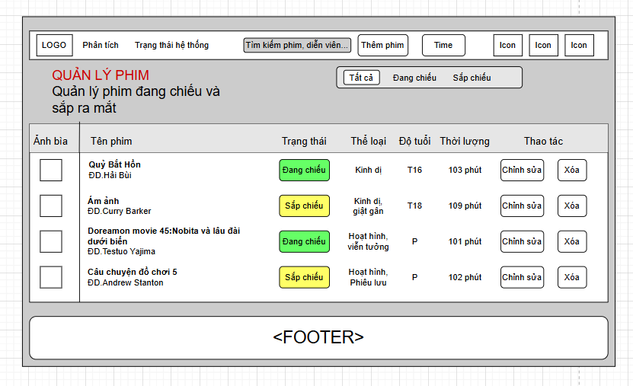

Field Name | Field Type | Description
Title | Heading | Display the title “Quản lý phim” of the movie management screen
“Tìm kiếm phim, diễn viên…” field | Search box | Allow Admin to search movies by movie title or actor name
“Tất cả” field | Tab/Radio button | Add to the filter to display alls movies
“Đang chiếu” field | Tab/Radio button | Add to the filter to display movie that currently showing
“Sắp chiếu” field | Tab/Radio button | Add to the filter to display movie that are coming soon
Thêm phim | Button | Button to negative to the screen for adding a new movie
Ảnh bìa | Picture | Checkbox to select one movie to perform bulk actions
Tên phim | Text | Display the movie’s title and its director
Tình trạng | Text | Display the release status of the movie (Đang chiếu/ Sắp chiếu)
Thể loại | Text | Display the genre of the movies
Độ tuổi | Text | Display the age-rating requirement of the movie
Thời lượng | Text | Display the duration of the movie in minutes
Thao tác | Text | Display choices whether to edit or delete the movie posting
Chỉnh sửa | Button | Button to negative to the screen for editing the movie’s detailed information
Xóa | Button | Button to delete the movie posting
Error Message | Text | Displays error messages"Không thể kết nối đến máy chủ. Vui lòng kiểm tra lại kết nối Internet” when system can not connect to database

Database Access
Table | CRUD | Description
Movie | R | Select all table movie

SQL Commands
Select all table job
SELECT * FROM [movies]

1.2 View movie post

UI Design
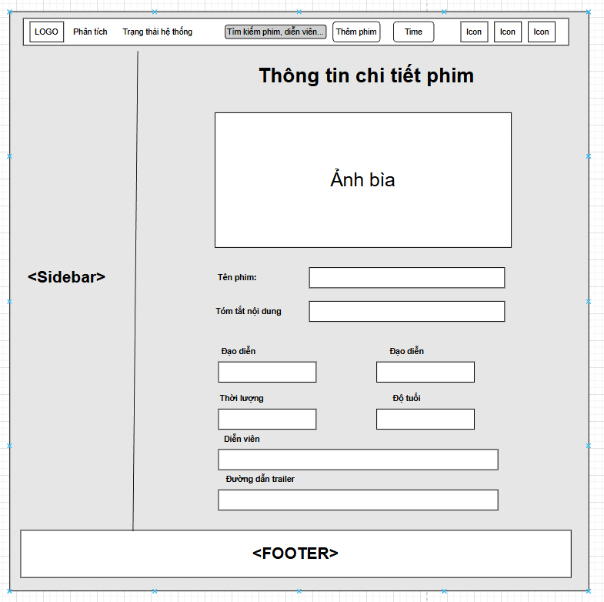

Field Name | Field Type | Description
Ảnh bìa | Image | Display the movie's poster image
Tên phim | Text | Display the movie's title
Tóm tắt nội dung | Text | Display the movie's synopsis/description
Đạo diễn | Text | Display the movie's director name
Trạng thái | Text/Badge | Display the release status of the movie (Đang chiếu / Sắp chiếu)
Thời lượng | Text | Display the movie's duration in minutes
Độ tuổi | Text | Display the movie's age-rating requirement (P, T13, T16, T18)
Diễn viên | Text | Display the movie's cast, separated by commas
Đường dẫn trailer | URL | Display the URL link to the movie's trailer video

Database Access
Table | CRUD | Description
Movie | C | Retrieve the selected movie's information (title, description, director, status, duration, age rating, poster, trailer) to display on the screen

SQL Commands:
1.Select all from movies table
SELECT * FROM movie WHERE MovieID = ?

2.Authentication

2.1. Register
Register new account to access features of the Platform

UI Design
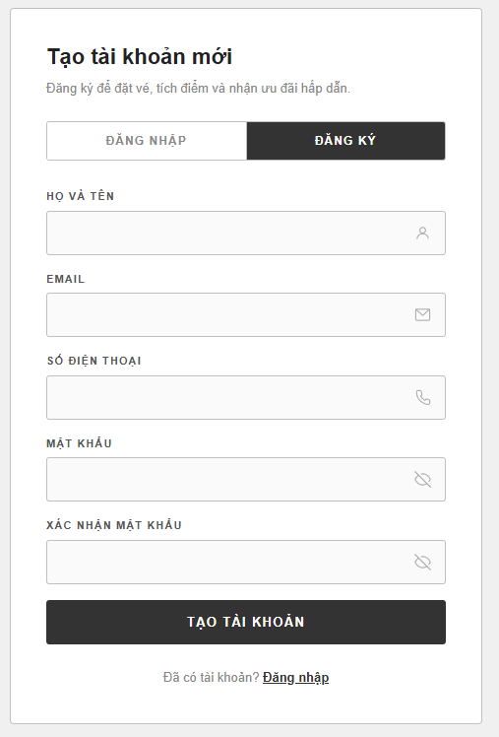

Field Name | Field Type | Description
Title | Heading | Display the text “Tạo tài khoản của bạn ngay bây giờ!”
Họ và tên* | Text Box | This is for the guest to input their full name
Email hoặc số điện thoại* | Text Box | This is for the guest to input a valid email address or phone number. Must follow email/phone format and must not already exist in the system
Mật khẩu* | Password Box | This is for the guest to input a password for the new account
Nhập lại mật khẩu* | Password Box | This is for the guest to re-enter the password; validated on the client side to match the “Mật khẩu” field
Đăng ký | Button | Guest clicks to validate and submit the registration form
Đăng nhập bằng Google | Button | Allow the guest to register/sign in using their Google account
Error Message | Text | Displays error message “Đăng ký thất bại” when the registration fails (e.g. email already exists, invalid format)
Success Message | Text | Displays confirmation message “Đăng ký thành công” when the registration is successful
Field Name | Field Type | Description

Database Access

Table | CRUD | Description
Users | R | Check whether the entered email/phone already exists in the system before creating the new account
Roles | R | Retrieve the RoleID of the ‘Customer’ role to assign to the new account
Users | C | Insert the new account (FullName, Email, PasswordHash, Phone, RoleID) into the Users table when the guest submits “Đăng ký”
Users | C | Insert the new account into the Users table when registering via Google (PasswordHash left NULL, account linked by Email)

1/ Check whether the email/phone already exists
SELECT UserID FROM Users WHERE Email = ?
2/ Retrieve the Customer RoleID
SELECT RoleID FROM Roles WHERE RoleName = 'Customer'
3/ Insert the new account (standard registration)
INSERT INTO Users (RoleID, FullName, Email, PasswordHash, Phone, IsActive)
VALUES (?, ?, ?, ?, ?, 1)
4/ Insert the new account (registration via Google)
INSERT INTO Users (RoleID, FullName, Email, PasswordHash, IsActive)
VALUES (?, ?, ?, NULL, 1)

2.2. Login
Any Users has account in the Platform, can access to the Platform by entering valid Username and password

UI Design
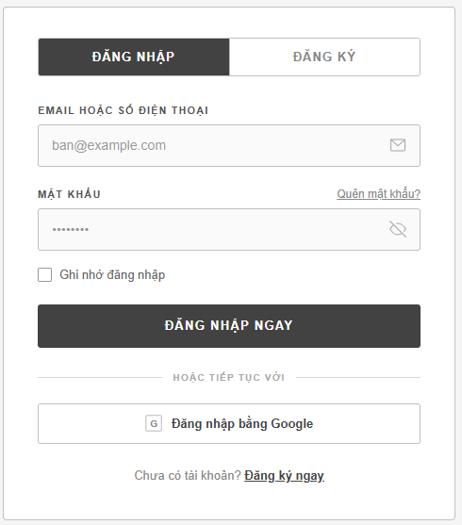

Field Name | Field Type | Description
Title | Heading | This field displays “Chúng tôi rất vui được gặp lại bạn”
Email hoặc số điện thoại | Input field | Field to input a valid email address or phone number registered in the system
Mật khẩu | Input field | Field to input the account's password. Must be at least 8 characters
Đăng nhập ngay | Button | Button to submit the login form and authenticate the user
Ghi nhớ đăng nhập | Check mark | Allows the user to stay logged in until the session expires
Quên mật khẩu? | Hyperlink | Allows the user to navigate to the password recovery flow
Đăng nhập bằng Google | Button | Allows the user to log in (or auto-register) using their Google account
Error Message | Text | Displays error message “Đăng nhập thất bại” when invalid credentials are detected
Success Message | Text | Displays confirmation message “Đăng nhập thành công” when login is successful

Database Access

Table | CRUD | Description
Users | R | Verify the entered Email/Phone and Password (PasswordHash) to authenticate the user during standard login
Users | R | Check whether the Google account's email already exists in the system (used for “Đăng nhập bằng Google”)
Users | C | Auto-create a new account when logging in with a Google email that does not yet exist in the system
Roles | R | Retrieve the role/authorizations of the logged-in user to determine access rights (Admin / Customer)

1.Verify UserName & Password information
SELECT UserID, FullName, Email, RoleID, AvatarURL, IsActive
FROM Users
WHERE (Email = ? OR Phone = ?)
AND PasswordHash = ?
AND ÍaCTIVE = 1
2.Check exist email
SELECT UserID FROM Users WHERE Email = ?
3.Add user by login google
INSERT INTO Users (RoleID, FullName, Email, PasswordHash, AvatarURL, IsActive) VALUES (?, ?, ?, Value, ?, 1)
4.Add user by login google
SELECT RoleName FROM Roles WHERE RoleID = ?

2.3. Logout
Log out the Platform

UI Design
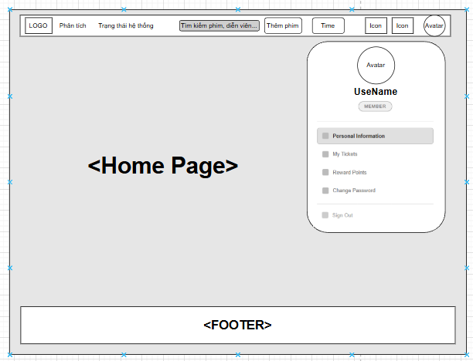

Field Name | Field Type | Description
Logout | Button | Button to submit the logout.

Database Access
None

2.4. Change password
Users can change their password if they want as long as they enter a valid old password.

UI Design

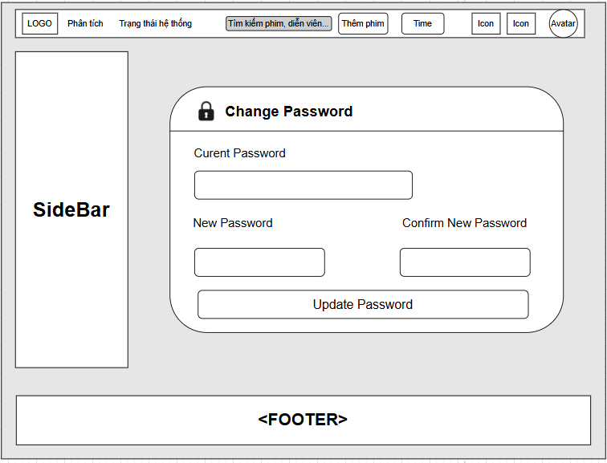

Field Name | Field Type | Description
Title | Heading | This field display “Change password ”
Current Password | Input field | Field for the user to enter their current password.
New Password | Input field | Field for the user to enter their new password.
Confirm New Password | Input field | Field for the user to enter to repeat their new password.
Update passwor | Button | Save changes new password
Error Message | Text | Displays error messages ”Đổi mật khẩu thất bại” when invalid input is detected.
Success Message | Text | Display confirmation message”Đổi mật khẩu thành công” when change password is successful.

Database Access

Table | CRUD | Description
Users | R | Update new password with valid email
1.Update new password with valid email

UPDATE [dbo].[Users] SET password = ? WHERE email = ?

2.5. Forgot password
When users log in if they forgot their password, they can request a verification mail to get an OTP then set a new password.

UI Design
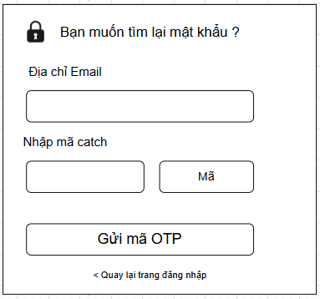
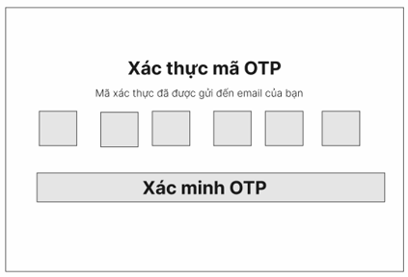
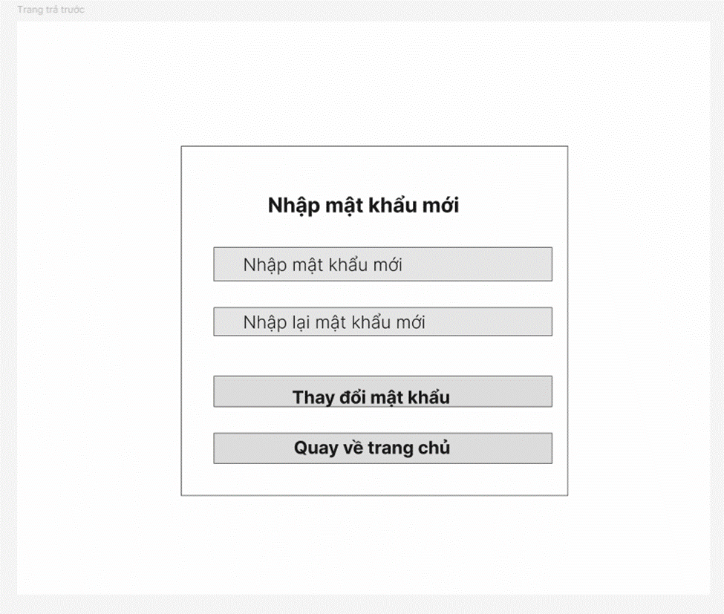

Field Name | Field Type | Description
Title | Heading | This field display “Nhập mã OTP”
Email | Input field | Field to input a valid email address. Must follow email format.
“Nhận OTP” button | Button | The system will send OTP to user via email
Error Message | Text | Displays error messages ”Email không đúng.Vui lòng thử lại” when invalid input is detected.

Field Name | Field Type | Description
Title | Heading | This field display “Xác thực mã OTP”
OTP input | Numerical | Enter OTP received via email
Error Message | Text | Displays error messages ”OTP không đúng.Vui lòng thử lại” when invalid is detected.
Verify OTP Button | Button | Verify an OTP to be sent to the email

Field Name | Field Type | Description
Title | Heading | This field display “Nhập mật khẩu mới”
New Password | Password Field | Field for the user to enter their new password.
Repeat New Password | Password Field | Field for the user to enter to repeat their new password.
Return home page | Button | Return to home page
Change Password Button | Button | Change to submit the new password
Error Message | Text | 1: Displays error messages when invalid ”Mật khẩu phải đủ 8 ký tự” input is detected.  2: Displays error messages when invalid ”Mật khẩu mới không trùng khớp” input is detected.
Success Message | Text | Display confirmation message”Đổi mật khẩu thành công” when changing password is successful.

Database Access

Table | CRUD | Description
Users | R | Select user with conditional email
User | U | Update password with email
1.Select user with condition email
SELECT * FROM [dbo].[Users] WHERE email = ?
2.Update password with email
UPDATE [dbo].[Users] SET password = ? WHERE email = ?

2.6. View profile
Any Users after login successfully can view their profile on the platform.

UI Design
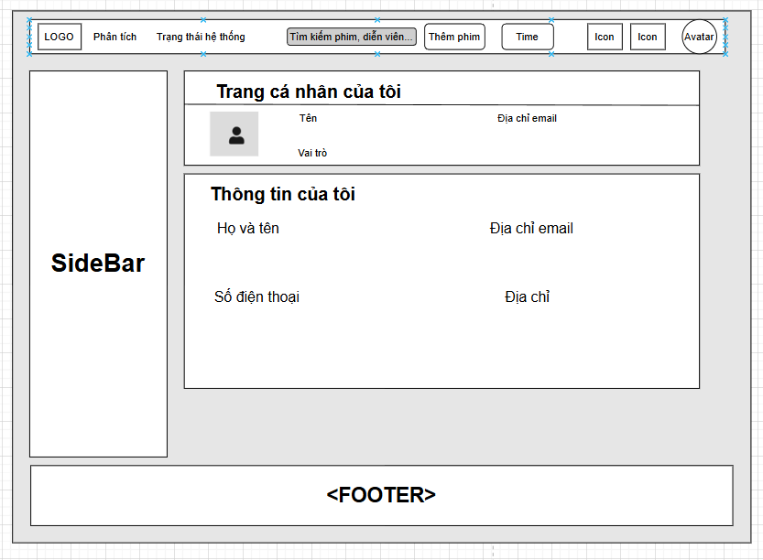

Field Name | Field Type | Description
Title | Heading | This field display “Trang cá nhân của tôi”
Avatar | Image | This field display “Ảnh đại diện người dùng
Tên | Text | Display user name
Email | Text | Display Email address
Vai trò | Text | Display role
Title | Text | This field display “Thông tin của tôi”
Địa chỉ | Text | Display user’s address
Số điện thoại | text | Display user’s phone number

Database Access

Table | CRUD | Description
Users | R | Select thông tin user theo UserID, join Roles để lấy tên vai trò

1.Select user with conditional user_id
SELECT u.UserID, u.FullName, u.Email, u.Phone, u.Address, u.AvatarURL, r.RoleName
FROM Users u
JOIN Roles r ON u.RoleID = r.RoleID
WHERE u.UserID = ?

2.7. Edit profile
Users can edit their information like change name, change date of birth...

UI Design
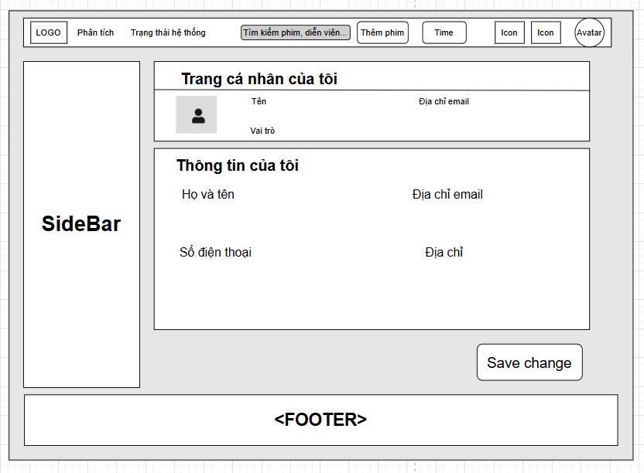

Field Name | Field Type | Description
Title | Heading | This field display “Trang cá nhân của tôi”
Avatar | Image | This field display “Ảnh đại diện người dùng
Tên | Text | Display user name
Email | Text | Display Email address
Vai trò | Text | Display role
Title | Text | This field display “Thông tin của tôi”
Địa chỉ | Text | Display user’s address
Số điện thoại | text | Display user’s phone number
Save changes | Button | Saves all edited information to the database

Database Access

Table | CRUD | Description
Users | R | Select user information by UserID to populate the form on page load
Users | U | Update user information by UserID when "Save change" is clicked

1. Retrieve current information to populate the form
SELECT u.UserID, u.FullName, u.Email, u.Phone, u.Address, u.AvatarURL, r.RoleName FROM Users u
JOIN Roles r ON u.RoleID = r.RoleID
WHERE u.UserID = ?
2. Update information when "Save change" is clicked
UPDATE Users SET FullName = ?, Email = ?, Phone = ?, Address = ?, AvatarURL = ? WHERE UserID = ?

3.Online Movie Management

3.1.Create Movie
Admin can create a new movie by entering its details, which will be stored in the system and made available for scheduling showtimes.

UI Design
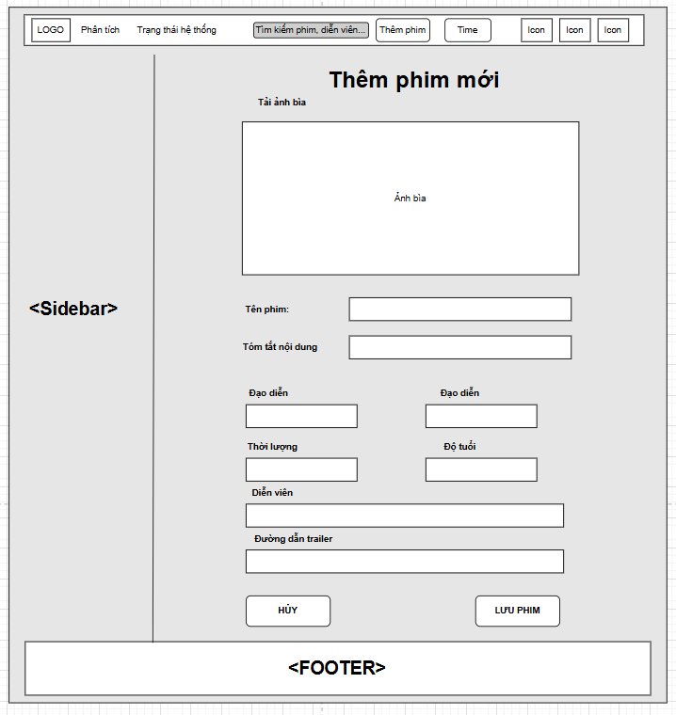

Field name | Filed type | Description
Title | Heading | Displays "Thêm phim mới" (Add New Movie)
Tải ảnh bìa | Input (File) | Upload the movie's cover/poster image, shown in preview box below
Tên phim | Text | Field to enter the movie's title
Tóm tắt nội dung | Text | Field to enter the movie's synopsis
Đạo diễn | Text | Field to enter the director's name
Thể loại (cần xác nhận) | Input | Field to select the movie's genre(s)
Thời lượng | Text | Field to enter the movie's duration in minutes
Độ tuổi | Text | Field to enter the age rating
Diễn viên | Text | Field to enter the main cast names
HỦY | Button | Cancels the operation and returns to the movie list without saving
LƯU PHIM | Button | Submits the form and saves the new movie to the database
Database Access

Table | CRUD | Description
Genres | R | Select available genres to populate the genre field
Movies | C | Insert a new movie record
Movie_Genres | C | Insert genre association(s) for the new movie
SQL Commands
1. Get available genres
SELECT GenreID, GenreName FROM Genres
2. Insert the new movie
INSERT INTO Movies (Title, Description, Director, Duration, AgeRating, TrailerURLPosterURL, MainCast, Status)
VALUES (?, ?, ?, ?, ?, ?, ?, ?, 'Coming Soon')
3. Link the new movie to selected genre(s)
INSERT INTO Movie_Genres (MovieID, GenreID)
VALUES (SCOPE_IDENTITY(), ?)

3.3.Delete Movie
Admin can delete Movie created

UI Design


Field Name | Field Type | Description
Title | Heading | Display the title “Quản lý phim” of the movie management screen
Chỉnh sửa | Button | Button to negative to the screen for editing the movie’s detailed information
Xóa | Button | Button to delete the movie posting

Database Access
Table | CRUD | Description
Showtime | D | delete Showtime by movie_id
Movie_Genre | D | delete Movie_Genre by movie_id
Movie | D | delete Movie by movie_id

SQL Commands;

Delete Showtime by movie_id:
DELETE FROM Showtime WHERE movie_id = ?;
Delete Movie_Genre by movie_id:
DELETE FROM Movie_Genre WHERE movie_id = ?;
Delete Movie by movie_id:
DELETE FROM Movie WHERE movie_id = ?;

3.4.Update Movie
Admin can update Movie

UI Design
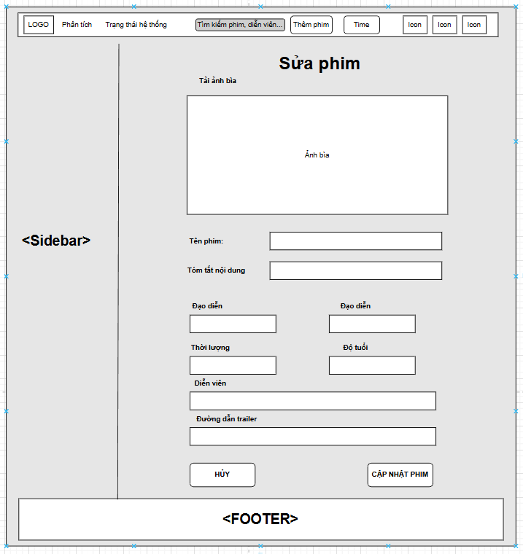

Field name | Filed type | Description
Title | Heading | Displays "Sửa phim"
Tải ảnh bìa | Input (File) | Upload the movie's cover/poster image, shown in preview box below
Tên phim | Text | Field to enter the movie's title
Tóm tắt nội dung | Text | Field to enter the movie's synopsis
Đạo diễn | Text | Field to enter the director's name
Thể loại (cần xác nhận) | Input | Field to select the movie's genre(s)
Thời lượng | Text | Field to enter the movie's duration in minutes
Độ tuổi | Text | Field to enter the age rating
Diễn viên | Text | Field to enter the main cast names
HỦY | Button | Cancels the operation and returns to the movie list without saving
CẬP NHẬT PHIM | Button | Submits the form and update movie to the database

Table | CRUD | Description
Movies | U | Update movie information by MovieID
Movie_Genres | D | Delete existing genre links for the given MovieID
Movie_Genres | C | Re-insert the newly selected genre links for the MovieID

SQL Commands:
Update movie information by MovieID
UPDATE Movies
SET Title = @Title,
Description = @Description,
Director = @Director,
Duration = @Duration,
AgeRating = @AgeRating,
TrailerURL = @TrailerURL,
PosterURL = @PosterURL,
MainCast = @MainCast
WHERE MovieID = @MovieID;
Remove the movie's existing genre links (before reassigning)
DELETE FROM Movie_Genres
WHERE MovieID = @MovieID;
Insert the newly selected genres (run once per selected GenreID)
INSERT INTO Movie_Genres (MovieID, GenreID)
VALUES (@MovieID, @GenreID);

4. Cinema management

4.1.View Cinema

UI Design
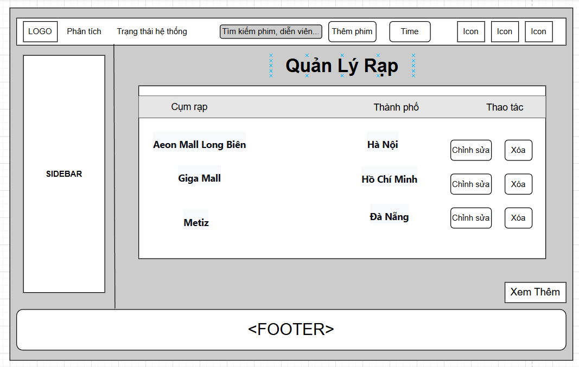
Field Name | Field Type | Description
Title | Heading | ❖ This field displays text: “Quản lý rạp”
Cụm rạp | Text | Displays the cinema branch name
Thành phố | Text | Displays the city the cinema is located in
Thao tác | Button | Contains "Chỉnh sửa" and "Xóa" buttons per row
Chỉnh sửa | Button | Navigates to the edit form for the selected cinema, pre-filled by CinemaID
Xóa | Button | Deletes the selected cinema by CinemaID, usually with a confirmation prompt
Xem Thêm | Button | Loads/paginates additional cinema rows

Database Access
Table | CRUD | Description
Cinemas | R | List all cinemas (paginated), with search by name/city
Cinemas | D | Delete a cinema by CinemaID
Rooms | R | Check whether the cinema has any rooms before allowing deletion (referential integrity)
SQL Commands
-List cinemas (paginated), optionally filtered by search keyword
SELECT CinemaID, CinemaName, City, Address
FROM Cinemas
WHERE (@Keyword IS NULL
OR CinemaName LIKE '%' + @Keyword + '%'
OR City LIKE '%' + @Keyword + '%')
ORDER BY CinemaID
OFFSET @Offset ROWS FETCH NEXT @PageSize ROWS ONLY;
-Check if the cinema has dependent rooms before deleting
SELECT COUNT(*) AS RoomCount
FROM Rooms
WHERE CinemaID = @CinemaID;
-Delete a cinema by CinemaID (only if no dependent rooms exist)
DELETE FROM Cinemas
WHERE CinemaID = @CinemaID;
4.2 Add Cinema
UI Design
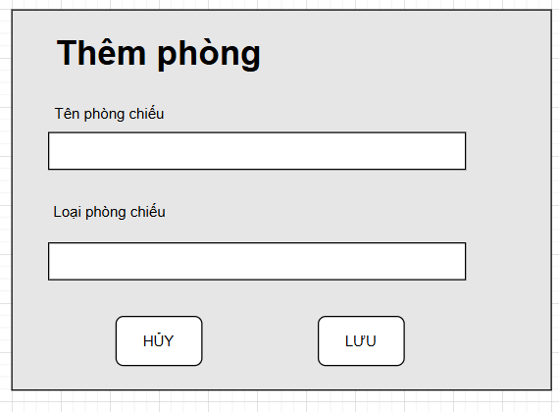

Field Name | Field Type | Description
Title | Heading | ❖ This field displays text: “Thêm phòng”
Tên phòng chiếu | Text | Field to enter the screening room's name
Loại phòng chiếu | Text/Select | Field to select or enter the room type (e.g. 2D Standard, IMAX, VIP Lounge, Sweetbox)
HỦY | Button | Cancels the operation and returns to the room list without saving
LƯU | Button | Submits the form and inserts a new room into the database
Database Acces

Table | CRUD | Description
Rooms | C | Insert a new room linked to a specific cinema
SQL Comment
Insert a new screening room
INSERT INTO Rooms (CinemaID, RoomName, TotalSeats, RoomType)
VALUES (@CinemaID, @RoomName, @TotalSeats, @RoomType);
4.3 Showtime list
UI Design
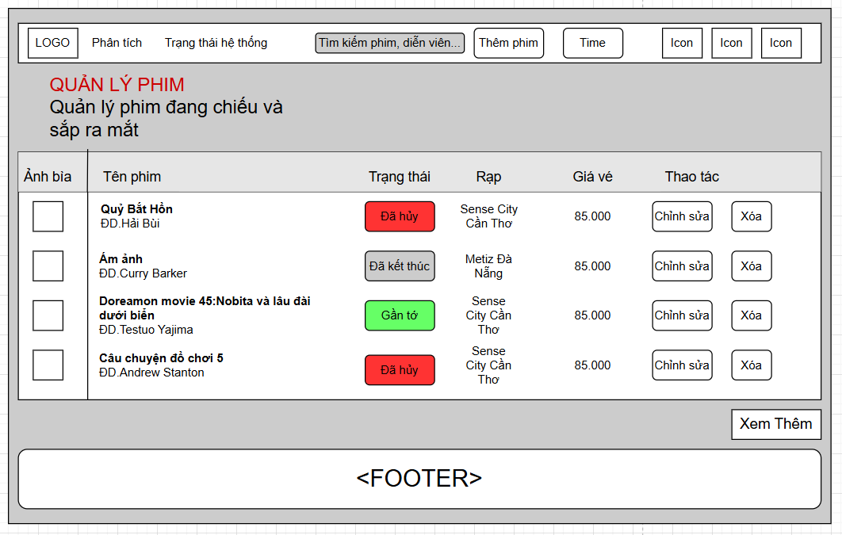

Field Name | Field Type | Description
Title | Heading | ❖ This field displays text: “Quản lý phim”
Tên phim | Text | Displays movie title and director
Trạng thái | Badge | Displays movie status with color coding
Rạp | Text | Displays the cinema showing the movie
Giá vé | Number | Displays the ticket price for a showtime
Thao tác | Button | "Chỉnh sửa" and "Xóa" buttons per row
Chỉnh sửa | Button | Navigates to the edit form for the selected movie, pre-filled by MovieID
Xóa | Button | Deletes/deactivates the selected movie by MovieID
Xem Thêm | Button | Loads/paginates additional movie rows
Database Access

Table | CRUD | Description
Movies | R | List all movies (paginated), with search by title/cast
Showtimes / Rooms / Cinemas | R | Join to fetch a representative cinema + price per movie
Movies | D | Delete or soft-delete a movie by MovieID
SQL Commands
List movies with their next/nearest showtime's cinema and price
SELECT m.MovieID, m.Title, m.Director, m.PosterURL, m.Status,
c.CinemaName, st.BasePrice
FROM Movies m
OUTER APPLY (
SELECT TOP 1 st.RoomID, st.BasePrice
FROM Showtimes st
WHERE st.MovieID = m.MovieID
ORDER BY st.StartTime ASC
) st
LEFT JOIN Rooms r ON r.RoomID = st.RoomID
LEFT JOIN Cinemas c ON c.CinemaID = r.CinemaID
WHERE (@Keyword IS NULL
OR m.Title LIKE '%' + @Keyword + '%'
OR m.MainCast LIKE '%' + @Keyword + '%')
ORDER BY m.MovieID
OFFSET @Offset ROWS FETCH NEXT @PageSize ROWS ONLY;
Soft-delete a movie
UPDATE Movies
SET Status = 'deleted'
WHERE MovieID = @MovieID;
4.4 Add showtime
UI Design
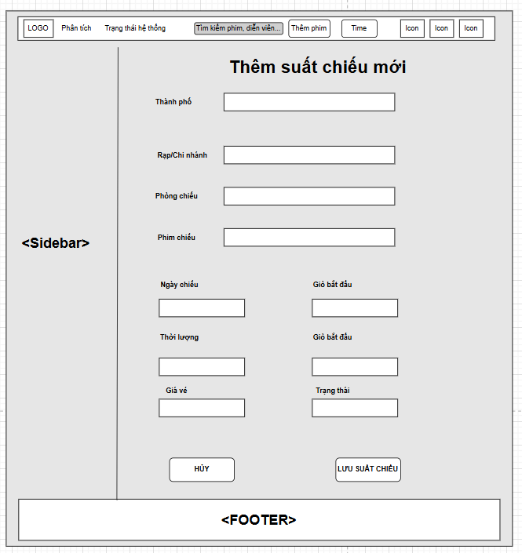

Field name | Filed type | Description
Title | Heading | Displays "Thêm suất chiếu mới"
Thành phố | Select (cascading) | Filters cinemas by city; not stored directly on Showtimes — used only to narrow down the "Rạp/Chi nhánh" dropdown → filters Cinemas.City
Rạp/Chi nhánh | Select (cascading) | Selects the cinema branch; filters the "Phòng chiếu" dropdown → filters Rooms.CinemaID
Phòng chiếu | Select (cascading) | Selects the screening room within the chosen cinema → Showtimes.RoomID
Phim chiếu | Select | Selects the movie to schedule → Showtimes.MovieID
Ngày chiếu | Date | Date of the showtime → part of Showtimes.StartTime
Giờ bắt đầu | Time | Start time of the showtime → part of Showtimes.StartTime
Thời lượng | Number | Movie duration in minutes, probably auto-filled from Movies.Duration and used to calculate the end time
Giờ kết thúc | Time | End time of the showtime → Showtimes.EndTime
Giá vé | Number | Base ticket price for this showtime → Showtimes.BasePrice
Trạng thái | Select | Showtime status (e.g. active, cancelled) → Showtimes.Status
HỦY | Button | Cancels the operation and returns to the showtime list without saving
LƯU SUẤT CHIẾU | Button | Submits the form and inserts a new showtime

Table | CRUD | Description
Cinemas | R | Populate city and cinema dropdowns
Rooms | R | Populate room dropdown filtered by selected cinema
Movies | R | Populate movie dropdown (only "Now Showing" / "Coming Soon" movies)
Showtimes | C | Insert a new showtime
Showtimes | R | Check for room/time conflicts before inserting
SQL Commands

Populate cinema dropdown filtered by city

SELECT CinemaID, CinemaName

FROM Cinemas

WHERE City = @City;

Populate room dropdown filtered by cinema

SELECT RoomID, RoomName, TotalSeats

FROM Rooms

WHERE CinemaID = @CinemaID;

Populate movie dropdown (active movies only)

SELECT MovieID, Title, Duration

FROM Movies

WHERE Status IN ('Now Showing', 'Coming Soon');

Check for scheduling conflicts in the selected room

SELECT COUNT(*) AS ConflictCount

FROM Showtimes

WHERE RoomID = @RoomID AND Status = 'active' AND (@StartTime < EndTime AND @EndTime > StartTime);

Insert the new showtime (only if no conflict found)

INSERT INTO Showtimes (MovieID, RoomID, StartTime, EndTime, BasePrice, Status)

VALUES (@MovieID, @RoomID, @StartTime, @EndTime, @BasePrice, @Status);

5. Booking Movie

5.1 Select Seat
Allows customer to choose seat in the cinema.

UI Design
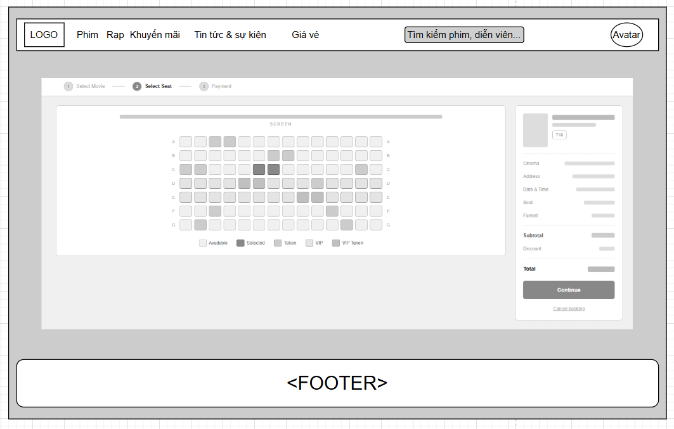

Field Name | Field Type | Description
Title | Heading | This field displays text: “Select seat”
Sơ đồ ghế | Grid/Button | Interactive grid of seat buttons; clicking toggles selection. Color-coded by status: Available, Selected, Taken, VIP, VIP Taken
Chú thích | Static | Displays color legend explaining each seat status
Movie info panel | Image/Static | Displays poster and age rating badge of the selected movie
Cinema | Text | Displays the selected cinema branch name
Address | Text | Displays the address of the selected branch
Date & Time | Text | Displays the selected showtime date and time
Seat | Text | Displays the list of currently selected seat codes (e.g. C5, C6)
Format | Text | Displays the screening format (2D/3D)
Subtotal | Text | Displays the sum of prices for selected seats
Discount | Text | Displays applied voucher/discount amount, if any
Total | Text | Displays final payable amount
Continue | Button | Proceeds to Payment step; locks selected seats for the customer
Cancel booking | Button | Cancels the current booking, releases held seats, returns to movie/showtime selection

Database Access
Table | CRUD | Description
Showtime_Seat | R | Read seat status list for the selected showtime_id
Showtime_Seat | U | Update seat status to 'Held' when a customer selects a seat (temporary lock)
Showtime_Seat | U | Update seat status back to 'Available' when a customer deselects a seat or cancels the booking
Booking | C | Insert a new booking record (status = Pending) when customer clicks "Continue"

SQL Commands:
-Read seat status by showtime_id:
SELECT seat_id, seat_code, seat_type, status, price
FROM Showtime_Seat
WHERE showtime_id = ?;
-Hold seat (on select):
UPDATE Showtime_Seat
SET status = 'Held', held_by = ?, held_until = DATEADD(MINUTE, 5, GETDATE())
WHERE showtime_id = ? AND seat_id = ? AND status = 'Available';
-seat (on deselect / cancel booking):
UPDATE Showtime_Seat
SET status = 'Available', held_by = NULL, held_until = NULL
WHERE showtime_id = ? AND seat_id = ? AND held_by = ?;
-Create booking draft (on Continue):
INSERT INTO Booking (customer_id, showtime_id, seat_ids, subtotal, discount, total, status, created_at)
VALUES (?, ?, ?, ?, ?, ?, 'Pending', GETDATE());

5.2 Paymaent
Allows customer pay the money.

UI Design
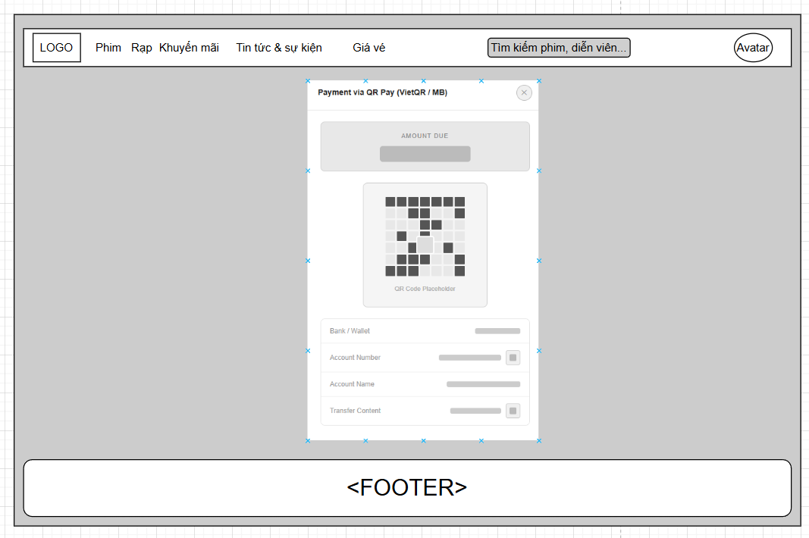

Field Name | Field Type | Description
Title | Heading | Displays "Payment via QR Pay (VietQR / MB)"
X (close) | Button/Icon | Closes the payment popup, cancels payment attempt (does not cancel the whole booking)
Amount due | Text | Displays the final total amount the customer must pay
QR Code | Image | Displays the generated VietQR/MB QR code encoding the amount and transaction content, for the customer to scan and pay
Bank / Wallet | Text | Displays the receiving bank name
Account Number | Text | Displays the merchant's receiving account number, with a copy icon
Account Name | Text | Displays the merchant's account holder name
Transfer Content | Text | Displays the required transfer note/content (e.g. booking code) so the payment gateway can match the transaction, with a copy icon

Database Access
Table | CRUD | Description
Booking | R | Read booking by booking_id to get total amount for generating QR
Payment | C | Insert a new Payment record (status = Pending) when the QR is generated
Payment | U | Update Payment status to 'Success' or 'Failed' once the payment gateway sends webhook callback
Booking | U | Update Booking status to 'Paid' after payment confirmation
Showtime_Seat | U | Update seat status from 'Held' to 'Sold' after payment confirmation

SQL Commands:
-Read booking amount by booking_id:
SELECT booking_id, total, transfer_content
FROM Booking
WHERE booking_id = ?;
-Create pending payment record:
INSERT INTO Payment (booking_id, amount, method, status, created_at)
VALUES (?, ?, 'VietQR_MB', 'Pending', GETDATE());
-Update payment status (called by payment gateway webhook):
UPDATE Payment
SET status = @status, paid_at = GETDATE()
WHERE payment_id = ?;
-Update booking status after successful payment:
UPDATE Booking
SET status = 'Paid'
WHERE booking_id = ?;
-Update seat status to Sold after successful payment:
UPDATE Showtime_Seat
SET status = 'Sold'
WHERE showtime_id = ? AND seat_id IN (?);

5.3 E-Ticket
Allows customer to view a ticket.

UI Design
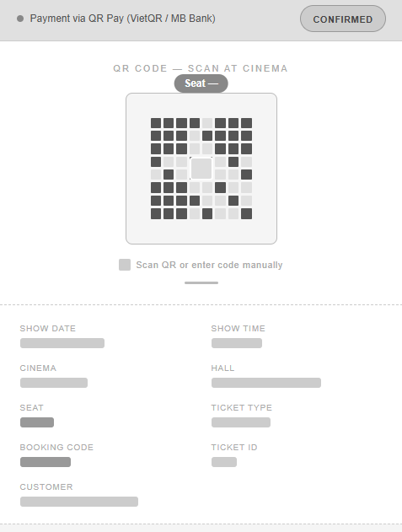

Field Name | Field Type | Description
Title | Heading | This field displays text: “Payment via QR Pay”
Status badge | Badge | Displays "CONFIRMED" status once payment succeeds
QR Code | Image | Displays the e-ticket QR code encoding the booking/ticket ID, scanned by cinema staff for entry check-in
Seat label | Static | Instructs staff/customer that the QR can be scanned or the code entered manually
Show date | Text | Displays the date of the screening
Show time | Text | Displays the start time of the screening
Cinema | Text | Displays the cinema branch name
Hall | Text | Displays the screening room/hall name
Seat | Text-area | Displays the seat code(s) booked
Ticket type | Text | Displays the ticket category (e.g. Standard, VIP, Couple)
Booking code | Text | Displays the unique booking reference code
Ticket ID | Text | Displays the unique ticket identifier
Customer | Text | Displays the customer's name on the booking

Database Access
Table | CRUD | Description
Ticket | C | Insert Ticket record(s) after payment confirmation (one row per seat)
Ticket | R | Read ticket details by booking_id to render the e-ticket screen
Booking | R | Read booking, showtime, cinema, hall, and customer info joined by booking_id

SQL Commands:
-Create ticket(s) after payment confirmation:
INSERT INTO Ticket (booking_id, seat_id, ticket_code, ticket_type, status, created_at)
VALUES (?, ?, ?, ?, 'Issued', GETDATE());
-Read e-ticket detail by booking_id:
SELECT
t.ticket_id,
t.ticket_code,
t.ticket_type,
s.date_show,
s.time_show,
c.cinema_name,
h.hall_name,
st.seat_code,
b.booking_code,
u.full_name AS customer_name
FROM Ticket t
JOIN Booking b ON t.booking_id = b.booking_id
JOIN Showtime s ON b.showtime_id = s.showtime_id
JOIN Cinema c ON s.cinema_id = c.cinema_id
JOIN Hall h ON s.hall_id = h.hall_id
JOIN Showtime_Seat st ON t.seat_id = st.seat_id
JOIN Customer u ON b.customer_id = u.customer_id
WHERE b.booking_id = ?;
-Check-in ticket at cinema (staff scans QR):
UPDATE Ticket
SET status = 'Checked_In', checked_in_at = GETDATE()
WHERE ticket_code = ? AND status = 'Issued';

6. Food & Beverage

6.1. Food & Beverage

UI Design:
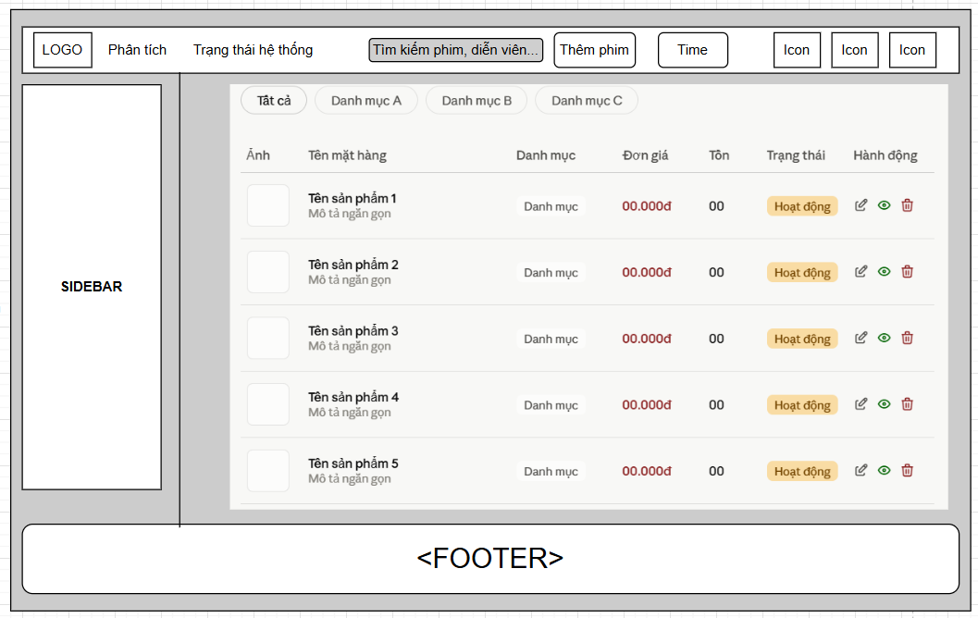

# | Component | Comp. Type | Description
1 | Tabs (Tất cả / Danh mục A / B / C) | Tab/Filter | Filters the product list by combo category
2 | Ảnh | Image | Displays the product's thumbnail image
3 | Tên mặt hàng | Text | Displays product name and a short description below it
4 | Danh mục | Text | Displays the category the product belongs to
5 | Đơn giá | Text | Displays the product's unit price
6 | Tồn | Text | Displays remaining stock/inventory quantity
7 | Trạng thái | Badge | Displays product status (e.g. Hoạt động / Ngừng bán)
8 | sửa | Button/Icon | Navigates to the edit-combo form
9 | xem | Button/Icon | Opens a read-only detail view of the product
10 | xóa | Button/Icon | Opens a confirmation dialog to delete the product

Database Access

Table | CRUD | Description
Combo | R | Read combo product list, optionally filtered by category_id
Combo_Category | R | Read category list to populate the filter tabs
Combo | D | Delete combo by combo_id (after confirmation)

SQL Commands

-Read combo list (all):
SELECT combo_id, image_url, name, description, category_name, unit_price, stock_qty, status
FROM Combo c
JOIN Combo_Category cc ON c.category_id = cc.category_id
ORDER BY c.created_at DESC;
-Read combo list filtered by category:
SELECT combo_id, image_url, name, description, category_name, unit_price, stock_qty, status
FROM Combo c
JOIN Combo_Category cc ON c.category_id = cc.category_id
WHERE c.category_id = ?
ORDER BY c.created_at DESC;
-Read category list (for tabs):
SELECT category_id, category_name FROM Combo_Category;
-Delete combo by combo_id:
DELETE FROM Combo WHERE combo_id = ?;

6.2 Food & Beverage view

UI Design
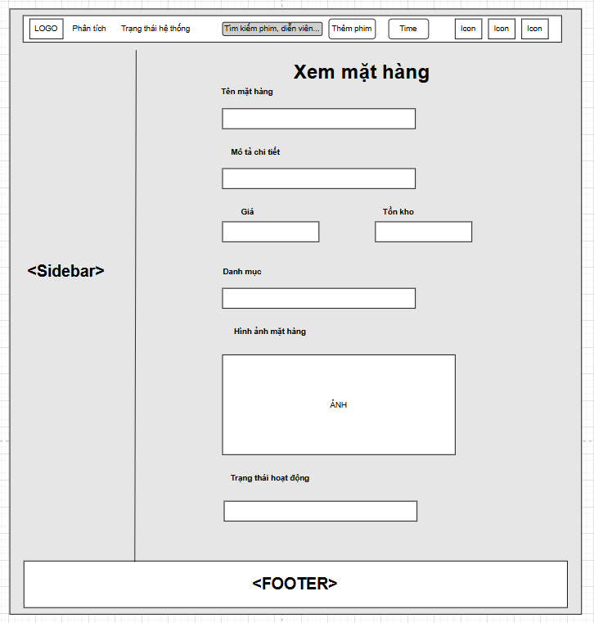
Field Name | Field Type | Description
Title | Heading | ❖ This field displays text: “Xem mặt hàng”
Tên mặt hàng | Text | Displays the product's name
Mô tả chi tiết | Text | Displays the product's detailed description
Giá | Text | Displays the product's unit price
Tồn kho | Text | Displays the current stock quantity
Danh mục | Text | Displays the category the product belongs to
Hình ảnh mặt hàng | Image | Displays the product's image
Trạng thái hoạt động | Text | Displays whether the product is active or discontinued

Database Access

Table | CRUD | Description
Combo | R | Read combo detail by combo_id
Combo_Category | R | Read category name by category_id

SQL Commands

-Read combo detail by combo_id:
SELECT
c.combo_id,
c.name,
c.description,
c.unit_price,
c.stock_qty,
cc.category_name,
c.image_url,
c.status
FROM Combo c
JOIN Combo_Category cc ON c.category_id = cc.category_id
WHERE c.combo_id = ?;

6.3 Food & Beverage update
Allows the employer, seeker, admin to send and receive the message from another user.

UI Design
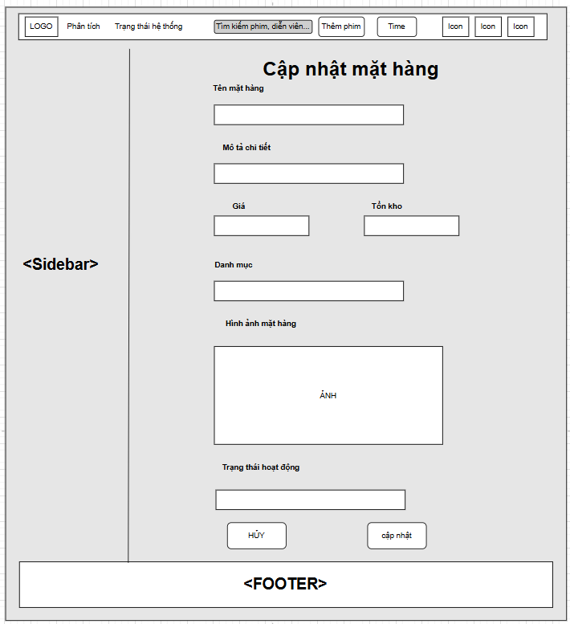

Field Name | Field Type | Description
Title | Heading | ❖ This field displays text: “Cập nhật mặt hàng”
Tên mặt hàng | Text | Displays the product's name
Mô tả chi tiết | Text | Displays the product's detailed description
Giá | Text | Displays the product's unit price
Tồn kho | Text | Displays the current stock quantity
Danh mục | Text | Displays the category the product belongs to
Hình ảnh mặt hàng | Image | Displays the product's image
Trạng thái hoạt động | Text | Displays whether the product is active or discontinued
HỦY | Button | Cancels the operation and returns to the product list without saving
CẬP NHẬT | Button | Submits the form and updates the product in the database

Database Access

Table | CRUD | Description
Combo | U | Update combo by combo_id

-Update combo by combo_id:
UPDATE Combo
SET name = @name,
description = @description,
unit_price = @unit_price,
stock_qty = @stock_qty,
category_id = @category_id,
image_url = @image_url,
status = @status
WHERE combo_id = ?;

6.4 Create new Food & Beverage

UI Design
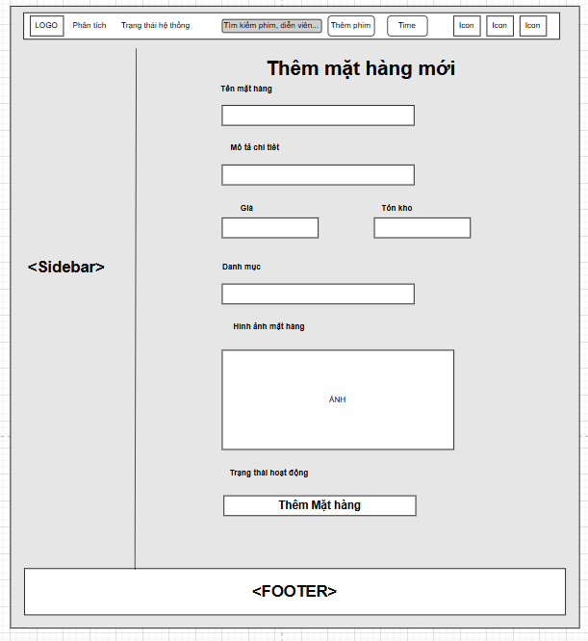

Field Name | Field Type | Description
Title | Heading | ❖ This field displays text: “Thêm mặt hàng mới”
Tên mặt hàng | Text | Displays the product's name
Mô tả chi tiết | Text | Displays the product's detailed description
Giá | Text | Displays the product's unit price
Tồn kho | Text | Displays the current stock quantity
Danh mục | Text | Displays the category the product belongs to
Hình ảnh mặt hàng | Image | Displays the product's image
Trạng thái hoạt động | Text | Displays whether the product is active or discontinued
Thêm mặt hàng | Button | Submits the form and inserts the new product into the database

Database Access

Table | CRUD | Description
Combo | C | Insert new combo record
Combo_Category | C | Insert new category (only if user adds one via the "Thêm" popup)

-Insert new combo:
INSERT INTO Combo (name, description, unit_price, stock_qty, category_id, image_url, status, created_at)
VALUES (?, ?, ?, ?, ?, ?, ?, GETDATE());
-Insert new category (via quick-add popup)
INSERT INTO Combo_Category (category_name) VALUES (?);

7. Voucher

7.1 View voucher list

UI Design
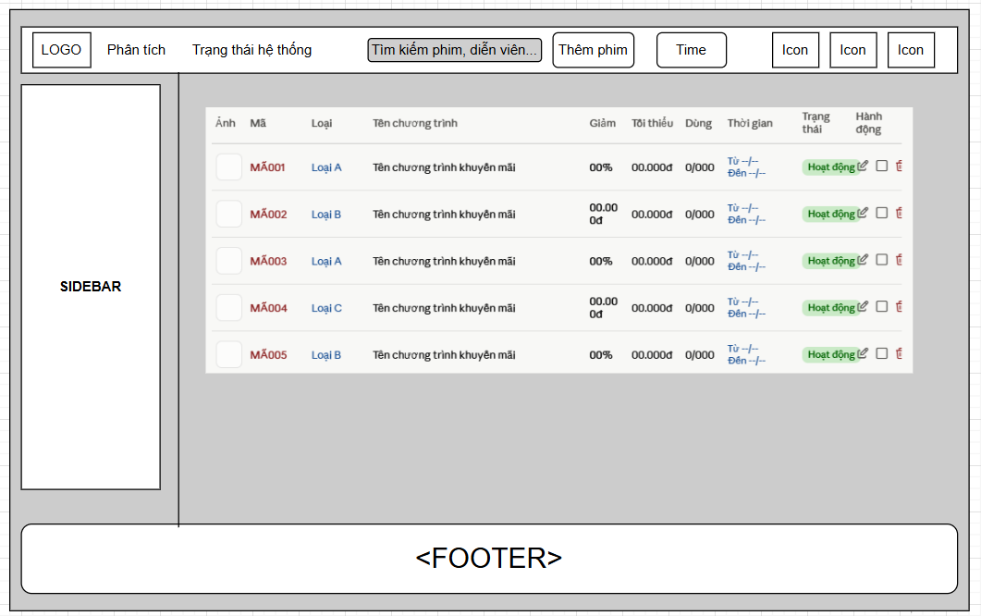

Field Name | Field Type | Description
Ảnh | Image | Displays the promotion's banner/icon image
Mã | Text | Displays the unique voucher code
Loại | Text | Displays the voucher type/category (e.g. Loại A, B, C)
Tên chương trình | Text | Displays the promotion campaign name
Giảm | Text | Displays the discount value (percentage or fixed amount)
Tối thiểu | Text | Displays the minimum order value required to apply the voucher
Dùng | Text | Displays usage count vs. usage limit (e.g. 0/000)
Thời gian | Text | Displays the voucher's valid start and end dates
Trạng thái | Badge | Displays voucher status (e.g. Hoạt động / Hết hạn)
sửa | Button/Icon | Navigates to the edit-voucher form
xem | Button/Icon | Opens a read-only detail view of the voucher
xóa | Button/Icon | Opens a confirmation dialog to delete the voucher

Database Access
Table | CRUD | Description
Voucher | R | Read voucher list, optionally filtered/sorted
Voucher | D | Delete voucher by voucher_id (after confirmation)
Voucher | U | Update status for selected voucher(s) via checkbox (bulk deactivate)

SQL Commands:

-Read voucher list:
SELECT voucher_id, image_url, voucher_code, voucher_type, campaign_name,
discount_value, discount_type, min_order_value, usage_count, usage_limit,
valid_from, valid_to, status
FROM Voucher
ORDER BY created_at DESC;
-Delete voucher by voucher_id:
DELETE FROM Voucher WHERE voucher_id = ?;
-Bulk update status for selected vouchers (checkbox action):
UPDATE Voucher
SET status = 'Ngừng áp dụng'
WHERE voucher_id IN (?);

7.2 View voucher

UI Design
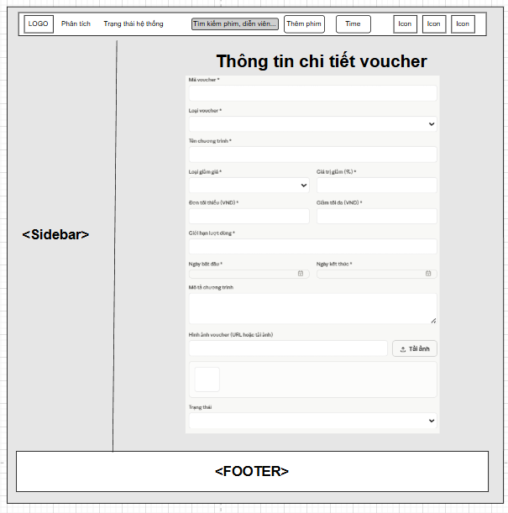

Field Name | Field Type | Description
Title name | Heading | This field displays text: “Thông tin chi tiết voucher”
Mã voucher | Text | Field to enter the unique voucher code (required)
Loại voucher | Input | Field to select the voucher type/category (required)
Tên chương trình | Text | Field to enter the promotion campaign name (required)
Loại giảm giá | Input | Field to select discount type (e.g. Percent / Fixed amount) (required)
Giá trị giảm | Number | Field to enter the discount value, matching the selected discount type (required)
Đơn tối thiểu | Number | Field to enter the maximum discount amount cap (required)
Giảm tối đa | Number | This button allows the admin to view users as role employer.
Giới hạn lượt dùng | Number | Field to enter the maximum number of times the voucher can be used (required)
Ngày bắt đầu | Date | Date
Ngày kết thúc | Date | Field to select the voucher's valid end date (required)
Mô tả chương trình | Text | Field to enter additional description of the promotion (optional)
Hình ảnh voucher (URL hoặc tải ảnh) | Text / Input (File) | Field to enter an image URL, or use "Tải ảnh" button to upload an image; preview shown below
Tải ảnh | Button | Opens file picker to upload a voucher image
Trạng thái | Input | Field to select voucher status (e.g. Hoạt động / Ngừng áp dụng)

Database Access
Table | CRUD | Description
Voucher | U | Update voucher by voucher_id (Edit mode)
Voucher | C | Insert new voucher record (Add mode)
Voucher | R | Read voucher detail by voucher_id (Edit mode, to pre-fill form)

SQL Commands:

-Insert new voucher:
INSERT INTO Voucher (voucher_code, voucher_type, campaign_name, discount_type,
discount_value, min_order_value, max_discount_value, usage_limit,
valid_from, valid_to, description, image_url, status, created_at)
VALUES (?, ?, ?, ?, ?, ?, ?, ?, ?, ?, ?, ?, ?, GETDATE());
-Update voucher by voucher_id:
UPDATE Voucher
SET voucher_code = @voucher_code,
voucher_type = @voucher_type,
campaign_name = @campaign_name,
discount_type = @discount_type,
discount_value = @discount_value,
min_order_value = @min_order_value,
max_discount_value = @max_discount_value,
usage_limit = @usage_limit,
valid_from = @valid_from,
valid_to = @valid_to,
description = @description,
image_url = @image_url,
status = @status
WHERE voucher_id = ?;
-Read voucher detail by voucher_id:
SELECT * FROM Voucher WHERE voucher_id = ?;

7.3 Update voucher
Allows admin to update voucher.

UI Design
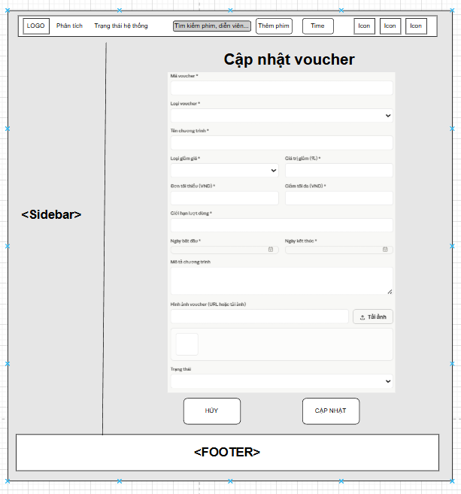

Field Name | Field Type | Description
Title name | Heading | This field displays text: “Cập nhật voucher”
Mã voucher | Text | Field to enter the unique voucher code (required)
Loại voucher | Input | Field to select the voucher type/category (required)
Tên chương trình | Text | Field to enter the promotion campaign name (required)
Loại giảm giá | Input | Field to select discount type (e.g. Percent / Fixed amount) (required)
Giá trị giảm | Number | Field to enter the discount value, matching the selected discount type (required)
Đơn tối thiểu | Number | Field to enter the maximum discount amount cap (required)
Giảm tối đa | Number | This button allows the admin to view users as role employer.
Giới hạn lượt dùng | Number | Field to enter the maximum number of times the voucher can be used (required)
Ngày bắt đầu | Date | Date
Ngày kết thúc | Date | Field to select the voucher's valid end date (required)
Mô tả chương trình | Text | Field to enter additional description of the promotion (optional)
Hình ảnh voucher (URL hoặc tải ảnh) | Text / Input (File) | Field to enter an image URL, or use "Tải ảnh" button to upload an image; preview shown below
Tải ảnh | Button | Opens file picker to upload a voucher image
Trạng thái | Input | Field to select voucher status (e.g. Hoạt động / Ngừng áp dụng)
HỦY | Button | Cancels the operation and returns to the voucher list without saving
CẬP NHẬT | Button | Submits the form and updates the voucher in the database

Database Access
Table | CRUD | Description
Voucher | R | Read voucher detail by voucher_id to pre-fill the form
Voucher | U | Update voucher by voucher_id

SQL Commands:

-Read voucher detail by voucher_id:
SELECT * FROM Voucher WHERE voucher_id = ?;
-Update voucher by voucher_id:
UPDATE Voucher
SET voucher_type = @voucher_type,
campaign_name = @campaign_name,
discount_type = @discount_type,
discount_value = @discount_value,
min_order_value = @min_order_value,
max_discount_value = @max_discount_value,
usage_limit = @usage_limit,
valid_from = @valid_from,
valid_to = @valid_to,
description = @description,
image_url = @image_url,
status = @status
WHERE voucher_id = ?;

7.4 Add new voucher
UI Design
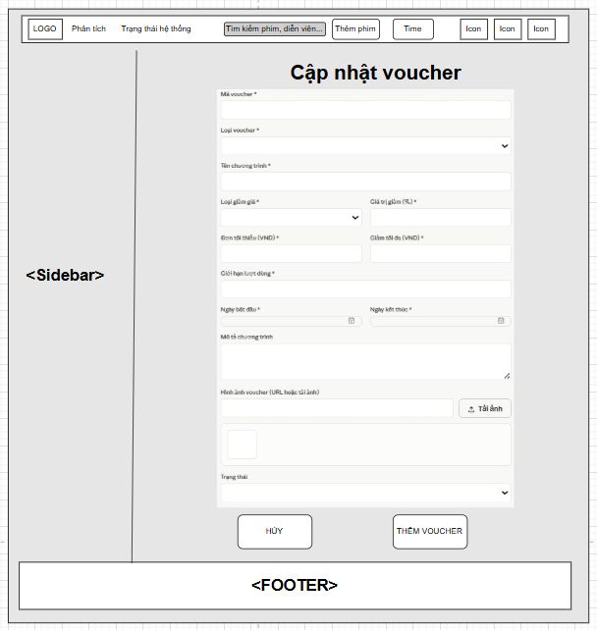

Field Name | Field Type | Description
Title name | Heading | This field displays text: “Cập nhật voucher”
Mã voucher | Text | Field to enter the unique voucher code (required)
Loại voucher | Input | Field to select the voucher type/category (required)
Tên chương trình | Text | Field to enter the promotion campaign name (required)
Loại giảm giá | Input | Field to select discount type (e.g. Percent / Fixed amount) (required)
Giá trị giảm | Number | Field to enter the discount value, matching the selected discount type (required)
Đơn tối thiểu | Number | Field to enter the maximum discount amount cap (required)
Giảm tối đa | Number | This button allows the admin to view users as role employer.
Giới hạn lượt dùng | Number | Field to enter the maximum number of times the voucher can be used (required)
Ngày bắt đầu | Date | Date
Ngày kết thúc | Date | Field to select the voucher's valid end date (required)
Mô tả chương trình | Text | Field to enter additional description of the promotion (optional)
Hình ảnh voucher (URL hoặc tải ảnh) | Text / Input (File) | Field to enter an image URL, or use "Tải ảnh" button to upload an image; preview shown below
Tải ảnh | Button | Opens file picker to upload a voucher image
Trạng thái | Input | Field to select voucher status (e.g. Hoạt động / Ngừng áp dụng)
HỦY | Button | Cancels the operation and returns to the voucher list without saving
THÊM VOUCHER | Button | Submits the form and add new voucher in the database

Database Access

Table | CRUD | Description
Voucher | C | Insert new voucher record
SQL Commands
-Insert new voucher:
INSERT INTO Voucher (voucher_code, voucher_type, campaign_name, discount_type,
discount_value, min_order_value, max_discount_value, usage_limit,
valid_from, valid_to, description, image_url, status, created_at)
VALUES (?, ?, ?, ?, ?, ?, ?, ?, ?, ?, ?, ?, ?, GETDATE());

IV. Appendix

1. Assumptions & Dependencies
Assumptions:
- AS-1: Customers, theater staff, and administrators have a stable Internet connection to access the CinemaVerse system, check showtimes, select seats in real-time, and make online payments.
- AS-2: Users possess basic computer literacy to use features such as searching for movies, selecting seat positions, applying voucher discount codes, and paying via bank QR codes.
- AS-3: Theater staff and Admins proactively participate in operating on-site processes (POS counter ticket sales, scanning ticket QR codes at auditorium gates, scheduling movie showtimes).
- AS-4: Information and data provided by users (registration email, phone number, booking information) are accurate and valid.
- AS-5: Automated authentication and payment reconciliation processes (via SePay/VietQR Webhook) are processed in a timely manner to ensure seat-holding performance and e-ticket generation.

Dependencies:
- DE-1: The project depends on modern web technologies (HTML5, CSS3, JavaScript ES6+, Socket.IO Client, and Node.js/Express) to develop the user interface and the real-time seat locking mechanism.
- DE-2: The platform utilizes a relational database management system (Microsoft SQL Server with the mssql connection pool) to store accounts, theater complexes, auditoriums, seat layouts, movie catalogs, showtimes, tickets, and payment history.
- DE-3: Support and integration from payment gateways/bank transfer services (such as SePay / VietQR / MoMo) are required to process automated financial transaction reconciliation between customers and the system.
- DE-4: Integration with a third-party email service (SMTP via Nodemailer) is required to automatically send 6-digit verification OTP codes, password recovery tokens, and E-ticket PDF files with embedded QR codes to customers.
- DE-5: The project depends on an AI service (Google Generative AI - Gemini 1.5/2.0 API) to operate the intelligent movie consultation chatbot and assist in answering user inquiries.

2. Limitations & Exclusions
LI-1 Mobile Application: The initial release version only supports a Responsive Web Application accessible via web browsers (Desktop, Tablet, Mobile); it does not include native mobile applications (iOS/Android native apps).
LI-2 Multi-Language Support: The platform initially supports only one language, which is Vietnamese (vi-VN); other languages will be expanded in future versions.
LI-3 Maximum Seats per Order: Each online ticket booking order is limited to a maximum of 8 seats per transaction to prevent commercial ticket scalping and speculative seat hoarding.
LI-4 Integration with External Job/Ticket Boards: The product does not support integration with cross-chain ticketing APIs or connections with third-party ticketing platforms in the first release.
LI-5 Offline Self-Service Kiosks: Hardware automated ticket vending machines (Kiosks) are not supported; direct ticket purchases at the theater are handled by Ticket Staff via the Staff POS interface.
LI-6 Social Media Direct Booking: Sharing movie links and trailers on social media is supported, but direct booking features embedded within social media platforms (Facebook/TikTok embedded checkout) are out of scope for this version.

3. Business Rules

ID | Category | Rule Definition
BR-01 | Validation | Notify the Customer with an error message MSG01 if the email format is entered incorrectly (e.g., name@domain.com).
BR-02 | Validation | Notify the User with MSG02 if the password does not meet the minimum length of 6 to 8 characters.
BR-03 | Integrity | Notify the Customer with MSG03 if the entered email is already registered as an account in the system.
BR-04 | Authorization | Notify the User with MSG04 if incorrect login information is entered; display MSG05 if login is successful and redirect to the corresponding homepage/admin page.
BR-05 | Validation | Notify the User with MSG06 if the incorrect old password is entered when performing a password change.
BR-06 | Validation | Notify with MSG07 if the email is unregistered during account recovery; display MSG08 when the OTP code is sent successfully.
BR-07 | Validation | Display MSG09 if OTP verification is successful; display MSG10 if the OTP code is incorrect or expired (limited to 5 minutes).
BR-08 | Validation | Notify the User with MSG11 if the re-entered password does not match the new password.
BR-09 | Action-Enabler | Display MSG12 if no matching movie or showtime search results are found.
BR-10 | Structural | Display the real-time seat map according to statuses: Available Seat (Standard/VIP/Couple), Holding (Blue/Temporarily locked), Sold (Red).
BR-11 | Performance | Ensure Socket.IO seat-locking response and broadcasting time is under 1 second (1000ms).
BR-12 | Integrity | The theater, auditorium, movie, and showtime must be selected from the active catalog; customers can select a maximum of 8 seats per order.
BR-13 | Validation | Display MSG13 if personal information or ticket booking information is incomplete when proceeding to payment.
BR-14 | Integrity | A movie ticket booking order must include: theater name, auditorium, showtime, selected seat list, total ticket amount, concessions (if any), voucher (if any), and payment method.
BR-15 | Action-Enabler | Display the ticket booking transaction history (including ticket code, movie name, showtime, amount, transaction date, status), filterable by date, up to 5 rows per page with 'Filter' and 'See More' options.
BR-16 | Notification | Notify the user with MSG14 if the movie post/showtime schedule is updated successfully, or MSG15 if the update fails.
BR-17 | Action-Enabler | Display a confirmation pop-up when deleting a showtime, movie post, or theater complex in the Admin page.
BR-18 | Action-Enabler | Display 'There are currently no showtimes for this movie.' if no matching schedule is available.
BR-19 | Integrity | Display MSG16 if a database connection error occurs while loading movie, seat, or showtime data.
BR-20 | Action-Enabler | Display an order information confirmation pop-up before proceeding to payment and generating the VietQR code.
BR-21 | Notification | Notify the customer with MSG17 when seats are successfully held for a duration of 5 minutes (300 seconds).
BR-22 | Structural | Display the auditorium seat layout in a grid format; Admin can view and edit seat types (Standard/VIP/Couple) and operational status.
BR-23 | Notification | Notify the Admin with MSG17 when a new showtime is created successfully, or MSG18 if there is an auditorium schedule conflict.
BR-24 | Action-Enabler | Display a confirmation pop-up when a customer submits an online ticket refund request.
BR-25 | Structural | Update order status: 'Pending' / 'Confirmed' / 'Cancelled' / 'Refunded'.
BR-26 | Action-Enabler | Display a confirmation pop-up for the Ticket Staff when canceling or rejecting an invalid ticket.
BR-27 | Structural | Display the payment page including the order summary, voucher input field, bank transfer VietQR code image, and transaction countdown timer.
BR-28 | Action-Enabler | Update payment results upon receiving the automated bank Webhook and switch the ticket status to 'Confirmed'.
BR-29 | Concurrency | The temporary seat holding time is 300 seconds (5 minutes); once this time expires, seats will automatically release back to 'Available Seat'.
BR-30 | Validation | Ensure uploaded movie poster images and profile avatars are in the correct format (JPG, PNG, WEBP) and within the size limit (under 5MB).
BR-31 | Status | Update the movie status in the catalog to 'Now Showing' / 'Coming Soon' / 'No Longer Showing'.
BR-32 | Validation | Ensure all mandatory fields in the payment information confirmation form are filled out.
BR-33 | Validation | The transfer amount in the QR/VietQR code must be exact according to the total order amount (minimum 10,000 VND).
BR-34 | Integrity | Display MSG19 if the discount code is invalid or expired; deduct the discount amount and display MSG20 if the code is valid.
BR-35 | Computation | Accumulate 1 reward point for every 10,000 VND spent on successful ticket and concession payments.
BR-36 | Authorization | Access control: Admin Dashboard is reserved exclusively for Admins; Staff POS for Staff/Admin; Guest/Customer can only access public pages.
BR-37 | Integrity | If the Gmail account matches a registered password account, the system will log into the same user profile.
BR-38 | Notification | Notify the customer with MSG21 when personal information is successfully updated and saved to the database.
BR-39 | Notification | Notify users when there is a new ticket notification or a reminder for an upcoming showtime.
BR-40 | Validation | Notify the user with MSG22 if the new password is identical to the old password.
BR-41 | Notification | Send a booking confirmation email along with a PDF E-ticket and QR code (MSG24) to the customer after payment.
BR-42 | Security | The QR code on the ticket is generated using a secure random method; each QR ticket can only be scanned and verified EXACTLY ONCE at the gate (Warning MSG24 upon re-scanning).

4. Application Messages List
# | Message Code | Message Type | Context | Content
1 | MSG01 | In line | Invalid email format when user fills out the email field | Sai định dạng email
2 | MSG02 | In line | Password does not meet the minimum length of 6-8 characters | Mật khẩu phải 8 kí tự trở lên
3 | MSG03 | Toast message | Email is already used when attempting to register | Email này đã được dùng để đăng kí
4 | MSG04 | Toast message | Login failed due to incorrect credentials | Đăng nhập thất bại
5 | MSG05 | Toast message | Login succeeded with correct credentials | Đăng nhập thành công
6 | MSG06 | Toast message | Password change failed | Đổi mật khẩu thất bại
7 | MSG07 | Toast message | Gmail has not been registered when attempting to retrieve account | Gmail chưa được đăng kí tài khoản
8 | MSG08 | Toast message | OTP sent successfully for account verification | Đã gửi mã OTP thành công
9 | MSG09 | Toast message | OTP verified successfully during account recovery | Xác thực OTP thành công
10 | MSG10 | Toast message | OTP verification failed during account recovery | Xác thực OTP thất bại
11 | MSG11 | In line | Re-entered password does not match the original password | Mật khẩu nhập lại không đúng
12 | MSG12 | Toast message | No movie or showtime search results found | 404 - Không tìm thấy kết quả nào
13 | MSG13 | In line | Profile or ticket checkout information is incomplete | Hãy điền đầy đủ thông tin
14 | MSG14 | Toast message | Movie catalog or showtime schedule updated successfully | Cập nhật bài đăng thành công
15 | MSG15 | Toast message | Movie catalog or showtime schedule update failed | Cập nhật bài đăng thất bại
16 | MSG16 | Toast message | Database connection error when performing an action | Lỗi kết nối cơ sở dữ liệu
17 | MSG17 | Toast message | Seat lock created successfully for 5 minutes | Đã giữ chỗ thành công! Thời gian giữ chỗ là 5 phút.
18 | MSG18 | Toast message | Failed to create a new showtime schedule due to hall conflict | Không thể tạo suất chiếu mới do trùng lịch
19 | MSG19 | Toast message | Voucher code invalid, expired, or conditions not met | Mã voucher không hợp lệ hoặc đã hết hạn
20 | MSG20 | Toast message | Payment completed successfully and ticket issued | Đã thanh toán thành công
21 | MSG21 | Toast message | Customer profile update and database save is successful | Cập nhật thông tin thành công
22 | MSG22 | In line | The re-entered password is the same as the old password. | Mật khẩu mới trùng với mật khẩu cũ.
23 | MSG23 | Pop up message | Staff QR Scanner notification for successful check-in | Vé xác thực thành công
24 | MSG24 | Pop up message | Staff QR Scanner notification for already used or invalid ticket | Vé không hợp lệ hoặc đã sử dụng trước đó

